Mexico City August 25th, 2015
The application of the second asphalt layer to the Autodromo Hermanos Rodriguez has begun.
- Progress of 90% on the Pit Building, 85% on Media Center and 98% on Nursery.
Last Friday began the tests required to adjust the asphalt plant for the second layer of the renewed track of the Autodromo Hermanos Rodriguez. This is a middle layer that works as a leveler, which is why it is used exclusively on track and not on the run offs or escapes. It is best known as “Binder” is 2cm thick and is processed differently from the fist layer, “Base Course” 5cm which is applied with an asphalt paving.
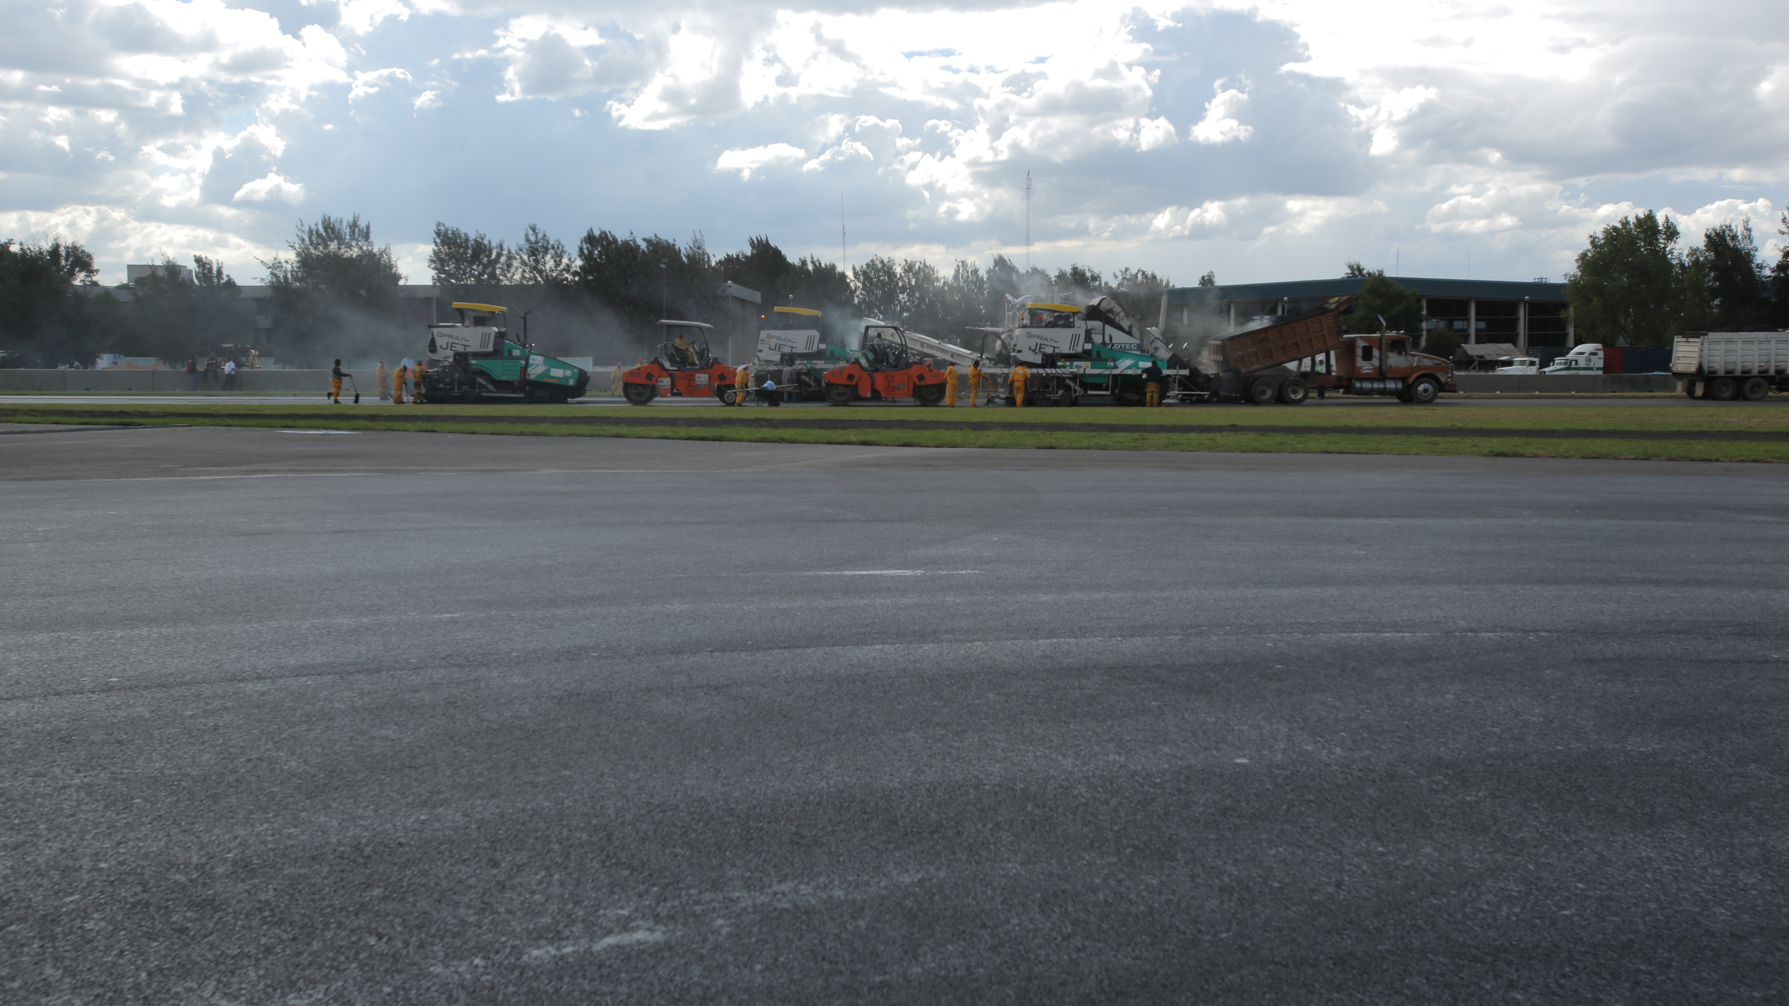
To carry out this process, three paving are used to avoid the longitudinal joint of fresh batch, and six steamrollers or compaction with tandem rollers, besides two transfer vehicles which are supplier machines that maintain the right temperature of the mixture and fill one by one. There is a fourth paving machine that will be used in Curve 1 which is one of the widest areas of the track with 19 meters. The asphalt mixture is used on the second and third layer, it is modified with polymers under FIA specifications to get the one degree approval in order to obtain the maximum category in motorsports.
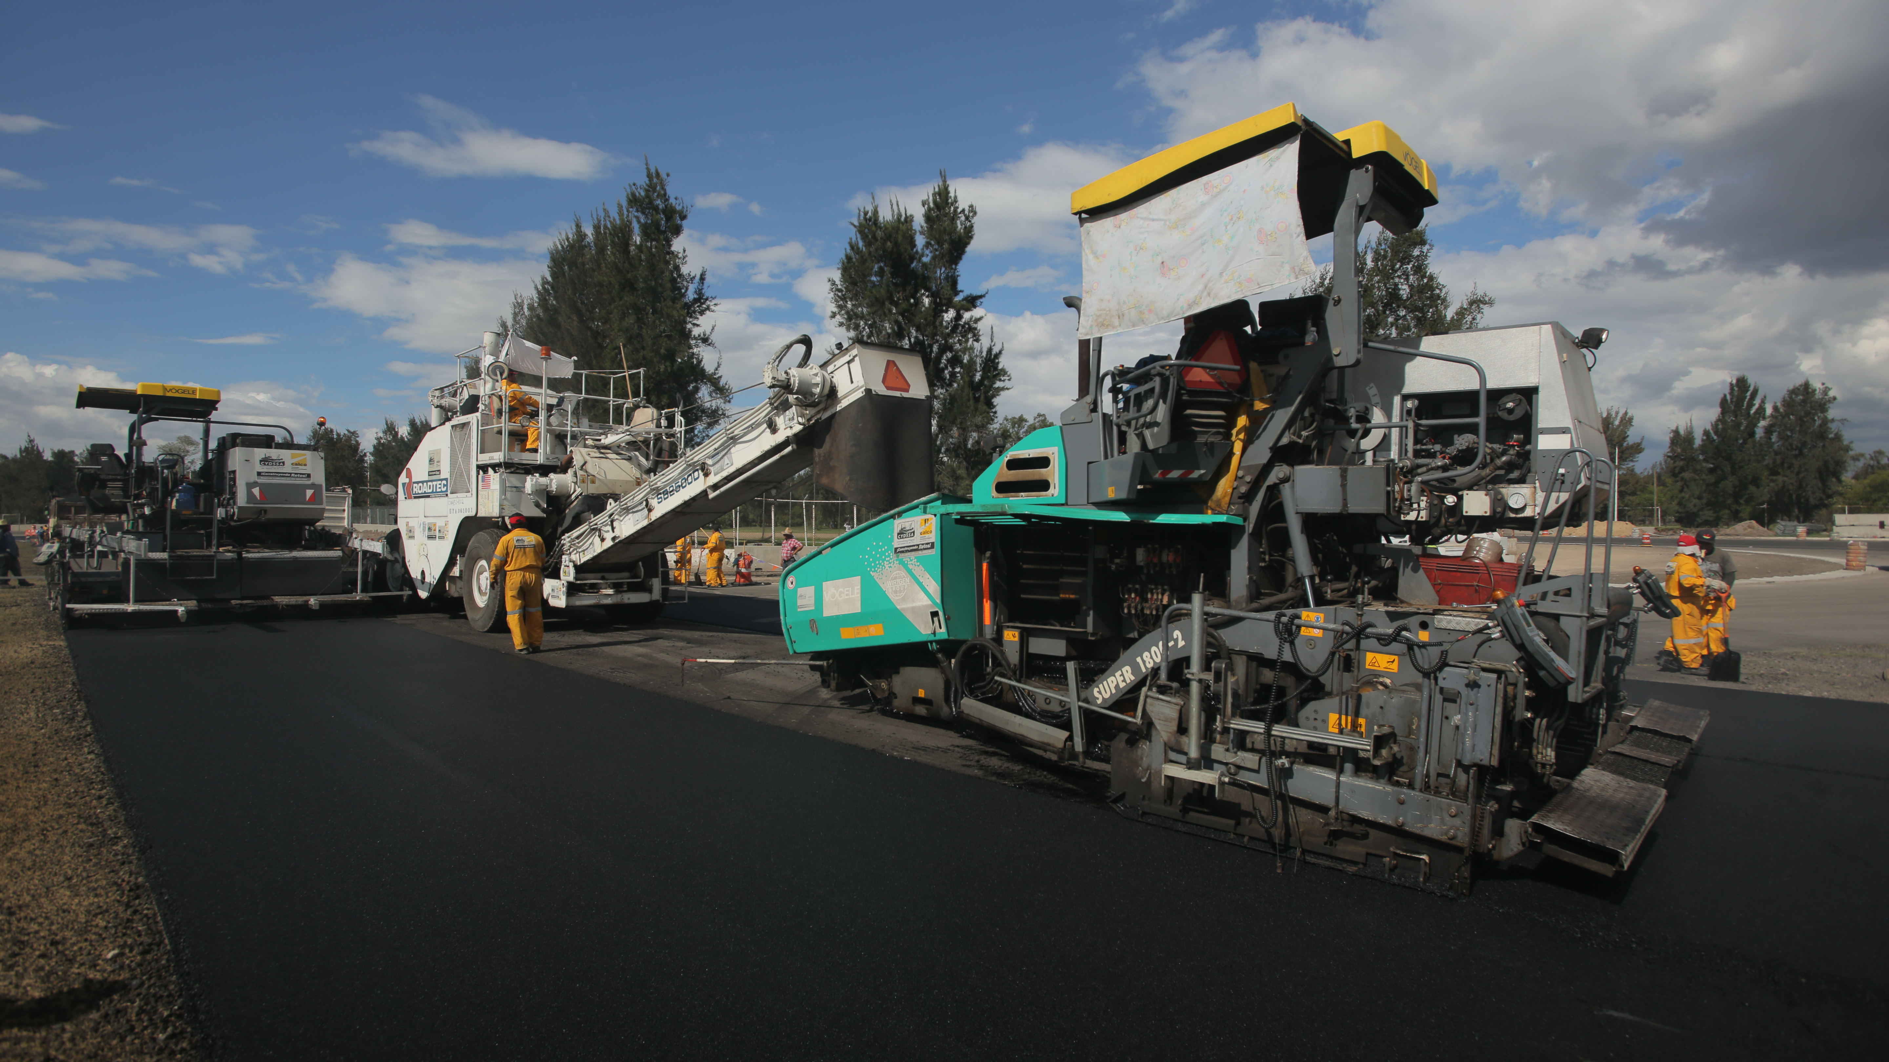
For this stage it is required over 50 workers and operators, besides supervisors. Once “Base Binder” is finished, the asphalt mixing plant will be calibrated again and placed at the complex Moises Solana to apply the last layer, the “Base Wearing” with 3cm thick.
As for the buildings, the current progress is 90 % on the Pit Building, 85% on the Media Center, and 98% on the Nursery.
Data of a workday:
4 pavings
2 transfer machines
14 asphalt rakers
20 trucks
50 people
250 m3 asphalt mixture

Visit and Enjoy Mexico with the FORMULA 1 GRAN PREMIO DE MÉXICO 2015®.
www.ahr.com.mx
Facebook: Autodromo Hnos Rodriguez
Instagram/Twitter: @autodromohr
#MexicoGP
RRPP Contacts
Francisco Velazquez  fvelazquezc@cie.com.mx  (52 55) 52019089  CIE | Manuel Orvañanos  Manuel@bandofinsiders.com  (52 55) 63.86.66.86  Band of Insiders

About Cie
Corporación Interamericana de Entretenimiento, S.A.B de C. V.
www.cie.com.mx
We are the market leader in outdoors entertainment in Mexico, Colombia and Central America and one of the most outstanding participants in Latin America and worldwide entertainment industry.
Through a unique vertical integration model, and the only Access to an important network of entertainment centers, a base of advertisers formed by the main advertising investors in our market, as well as the alliances and strategic partnerships that we have established with experienced participants in global industry; we offer different world-class entertainment options, which include concerts, theater productions, sports, family and cultural events, among others to satisfy leisure and recreation needs for our audiences.
We operate an amusement and an aquatic park in Bogota, Colombia. Also, we commercialize the Banamex Center in Mexico City, one of the biggest and most important exhibition and convention venues internationally. In addition we are recognized as the foremost producer and organizer of special and corporate events in Mexico, and for operating one of the most professional contact centers recognized in the Mexican Market.
CIE is a public Company whose shares and debit securities are listed in the Mexican Stock Exchange.

