**Charlie Whiting and Jean Todt guarantee progress in the Autodromo Hermanos Rodriguez**

* Progress at the Autódromo Hermanos Rodriguez impressed Whiting.
* Jean Todt verified progress on the new Control Tower.

As part of last week FIA activities, FORMULA 1® Race and Safety Director visited Autodromo Hermanos Rodriguez’ facilities.

*"I am impressed with the progress of works in general and with the quality and professionalism in which they are being carried out. I came just a month ago and the progress is significant”.* Pointed Whiting.

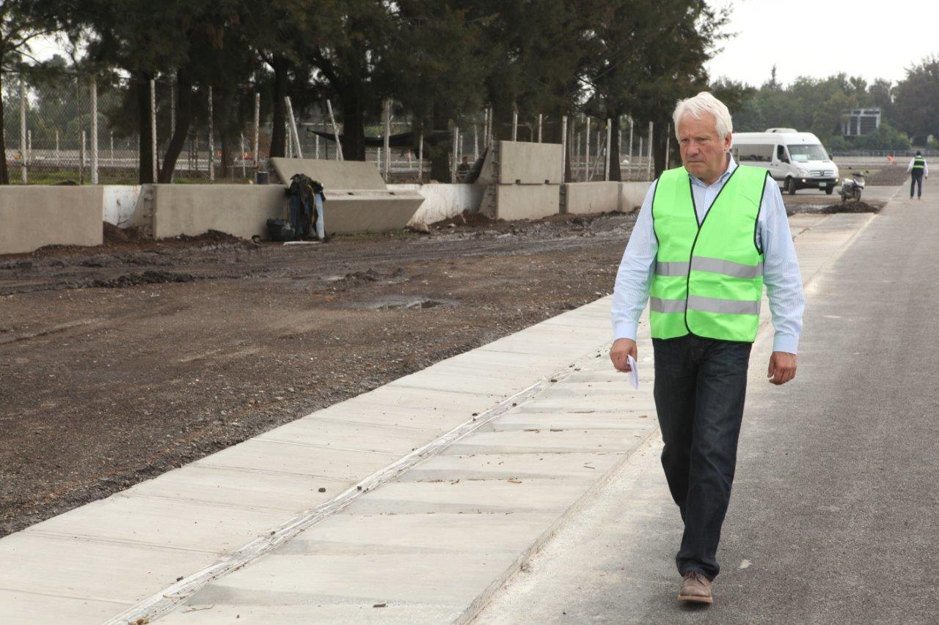

Whiting walked around 4.305 km of the renovated track and claimed to be calmed and confident that Works will be completed in time.

While, FIA President, Jean Todt, also attended Autódromo Hermanos Rodriguez’ facilities before leaving our country and noted the works made to the track, especially the progress in the New Control. Todt toured the Pit Building or Main Building, with over 25,000 m2 where the 33 pits or garages are placed and entered to what it will be the Timing and Race Control.

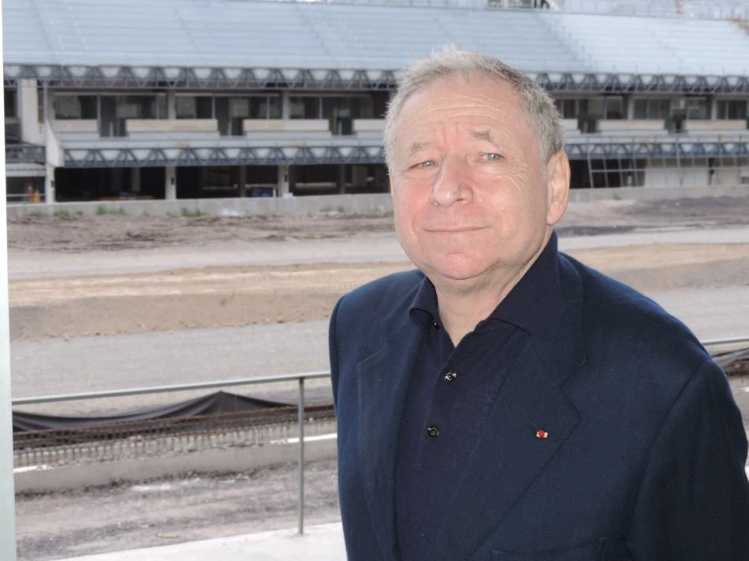

On the other hand, this weekend the first four of 30 trailers arrived charged with Tecpro, an impact absorbing material that will be placed in maximum security areas as much to the drivers as to attendants. The Tecpro has different measures and weight and it is the latest in security technology in the best tracks of the world.

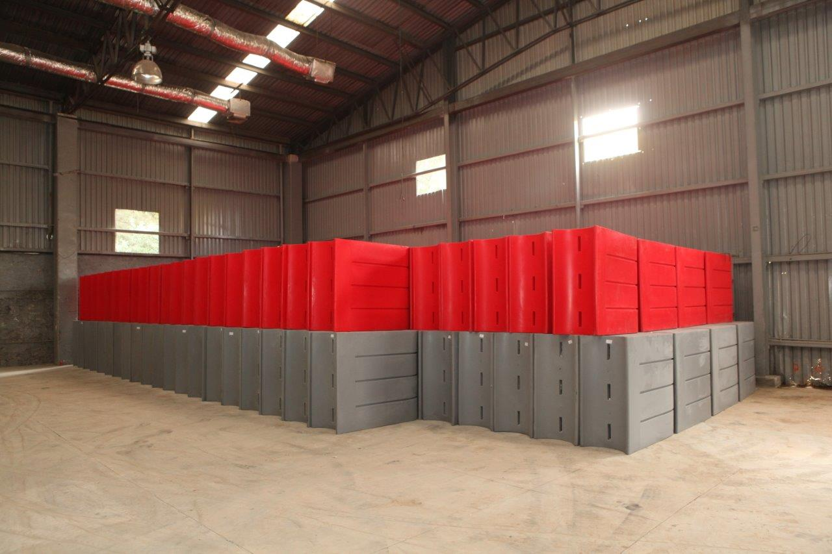

To download pictures and more information click on the following link:

*Visit and enjoy Mexico with the FORMULA 1 GRAN PREMIO DE MEXICO 2015*®*.*

[www.ahr.com.mx](http://www.ahr.com.mx)

Facebook: Hermanos Rodriguez

Instagram/Twitter: @autodromohr

#MexicoGP

**Contacts**

|  |  |
| --- | --- |
| Francisco Velazquez  [fvelazquezc@cie.com.mx](mailto:fvelazquezc@cie.com.mx)  (52 55) 52019089  CIE | Manuel Orvañanos  [manuel@bandofinsiders.com](mailto:manuel@bandofinsiders.com)  (52 55) 63866686  Band of Insiders |

**About CIE**

Corporación Interamericana de Entretenimiento, S.A.B de C. V.

[www.cie.com.mx](http://www.cie.com.mx)

We are the market leader in outdoors entertainment in Mexico, Colombia and Central America and one of the most outstanding participants in Latin America and worldwide entertainment industry.

Through a unique vertical integration model, and the only Access to an important network of entertainment centers, a base of advertisers formed by the main advertising investors in our market, as well as the alliances and strategic partnerships that we have established with experienced participants in global industry; we offer different world-class entertainment options, which include concerts, theater productions, sports, family and cultural events, among others to satisfy leisure and recreation needs for our audiences.

We operate an amusement and an aquatic park in Bogota, Colombia. Also, we commercialize the Banamex Center in Mexico City, one of the biggest and most important exhibition and convention venues internationally. In addition we are recognized as the foremost producer and organizer of special and corporate events in Mexico, and for operating one of the most professional contact centers recognized in the Mexican Market.

CIE is a public Company whose shares and debit securities are listed in the Mexican Stock Exchange.