Mexico City, August 31th, 2015

Charlie Whiting endorses progress at the Autodromo Hermanos Rodriguez 60 days away from the FORMULA 1 GRAN PREMIO DE MEXICO 2015®

Charlie Whiting, FORMULA 1® Race Director, visited the Autodromo Hermanos Rodriguez facilities again as part of the inspections carried out by FIA (International Automobile Federation) in the last months.

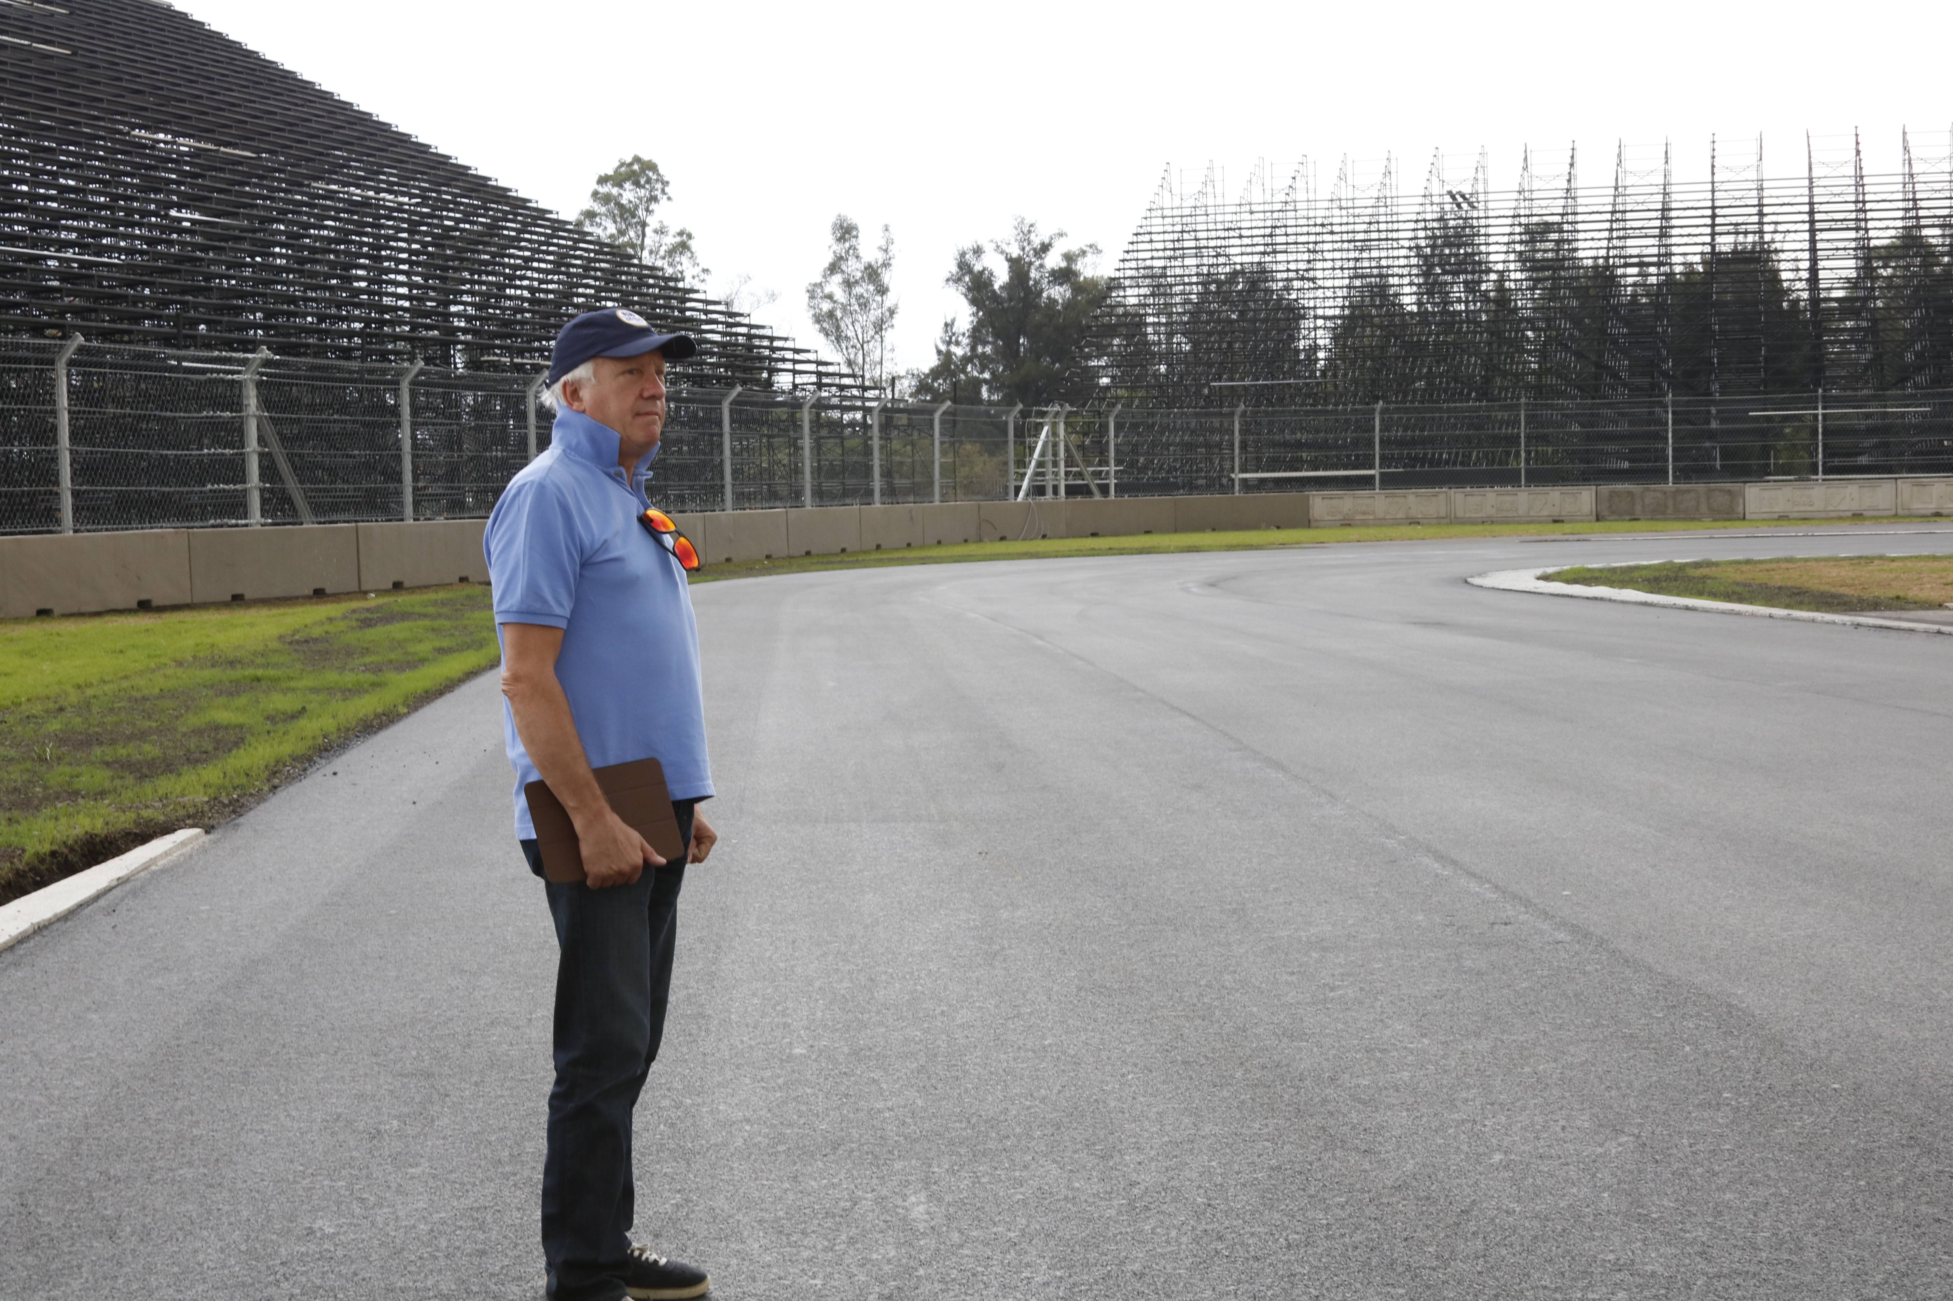

Only 60 days away from the FORMULA 1 GRAN PREMIO DE MEXICO 2015®, the also General for the Serial Security, stated “All the community of the FORMULA 1® is very excited to come to Mexico and see the Autodromo Hermanos Rodriguez, which will undoubtedly be scene for an excellent race”, pointed. “A huge effort on refurbishment works for the Autodromo Hermanos Rodriguez has been made, the place will definitely look spectacular for the race that weekend, I am certain it will be one of the most emblematic events of the year”, said.

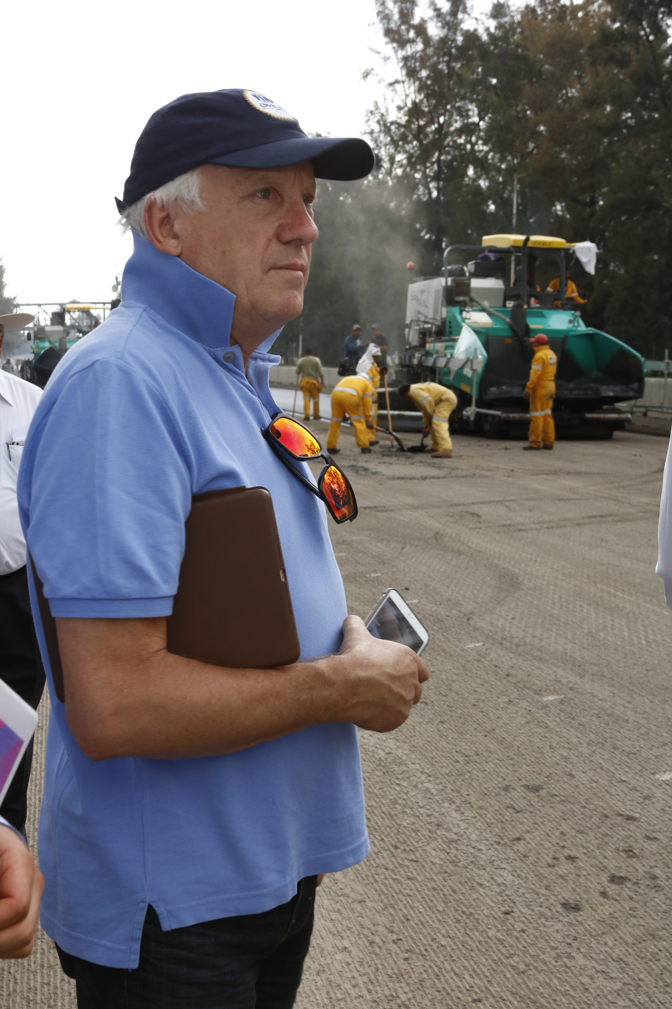

On the other hand, Whiting expressed to be satisfied with the results he could attest during his tour. “I can satisfactorily appreciate the placing of the voussoirs around the circuit, and the works that are being made to the protective mesh (FIA Fence) and finishing the kerbs (pianos or sinks) along the track”.

Christian Epp, Representative of Tilke for Latin America said “On his visit Charlie could attest the 95% of progress made to the Pit Building, 90% to the Media Center and the Nursery is almost finished”.

“Nowadays we are placing the second layer of asphalt on the track, as Charlie could witness in the straight after the curve number 3. Next week we will be able to begin placing the last layer, known as bearing layer”. Said.

Charlie Whiting completed one more visit to the renewed layout of the Autodromo Hermanos Rodriguez, place where he has walked around the 4.305 km distance of the circuit, to supervise even the last detail towards the FORMULA 1 GRAN PREMIO DE MEXICO 2015®.

And finally, Federico Gonzalez Compean, FORMULA 1 GRAN PREMIO DE MEXICO 2015® Director stated. “We are ready to receive this world class event, we have been working really hard for the people to enjoy this great experience brought by motor racing, which will undoubtedly be an unprecedented event”.

Visit and enjoy Mexico with the FORMULA 1 GRAN PREMIO DE MEXICO 2015®.
www.ahr.com.mx
Facebook: Autodromo Hnos Rodriguez
Instagram/Twitter: @autodromohr
#MexicoGP

Contact
Francisco Velazquez  fvelazquezc@cie.com.mx  (52 55) 52019089  CIE | Manuel Orvañanos  manuel@bandofinsiders.com  (52 55) 63866686  Band of Insiders

About Cie
Corporación Interamericana de Entretenimiento, S.A.B de C. V.
www.cie.com.mx

We are the market leader in outdoors entertainment in Mexico, Colombia and Central America and one of the most outstanding participants in Latin America and worldwide entertainment industry.
Through a unique vertical integration model, and the only Access to an important network of entertainment centers, a base of advertisers formed by the main advertising investors in our market, as well as the alliances and strategic partnerships that we have established with experienced participants in global industry; we offer different world-class entertainment options, which include concerts, theater productions, sports, family and cultural events, among others to satisfy leisure and recreation needs for our audiences.
We operate an amusement and an aquatic park in Bogota, Colombia. Also, we commercialize the Banamex Center in Mexico City, one of the biggest and most important exhibition and convention venues internationally. In addition we are recognized as the foremost producer and organizer of special and corporate events in Mexico, and for operating one of the most professional contact centers recognized in the Mexican Market.
CIE is a public Company whose shares and debit securities are listed in the Mexican Stock Exchange.

