Mexico City, October 28, 2015

How to read your ticket for the FORMULA 1 GRAN PREMIO DE MEXICO 2015®

If you are one of the lucky ones to have guaranteed access to the FORMULA 1 GRAN PREMIO DE MEXICO 2015®, we want to share the right way to read your ticket, so you correctly locate your seat and enjoy all the thrill of the FORMULA 1® comeback to our country.

For tickets purchased on the system Ticketfast:
- In the central part you will find your section, number of stand, the row and your corresponding seat number. (Number 1 of the graphic). In some sections, such as “General”, seats are not numbered.
- Below you will find the entrance door, the stand number and the access (Number 2 of the graphic). Remember there will be internal transportation from the different access gates of the Autodromo Hermanos Rodriguez to take you to the corresponding section indicated on your ticket.
- At the lower left you will find the date for your access (Number 3 of the graphic).
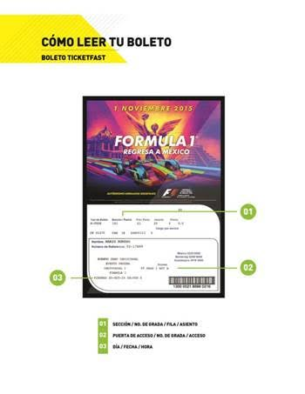

For tickets purchased on the system Ticketmaster:
- In the top central part you will find the section, the number of stand, the row and your corresponding seat. (Number 1 of the graphic). In some sections, such as “General”, seats are not numbered.
- At the lower right you may find the entrance door, the number of stand and the access (Number 2 of the graphic). Remember there will be internal transport from the different access gates of the Autodromo Hermanos Rodriguez to take you to the corresponding section indicated on your ticket.
- In the central part you may find you’re the color of seat section (Number 3 of the graphic). Remember there are seven sections divided into different colors all over the Autodromo Hermanos Rodriguez.
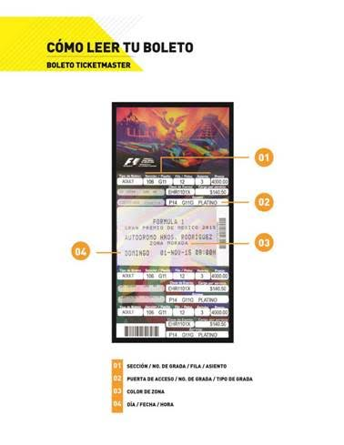
- Lower on the right side you will find the date for your access (Number 4 of the graphic).

Remember there is no parking lot in the facility, so we recommend the use of public transport.
You’re now ready to experience all the excitement of the FORMULA 1 GRAN PREMIO DE MEXICO 2015®!

Visit and Enjoy Mexico with the FORMULA 1 GRAN PREMIO DE MEXICO 2015®.
In case of further doubts please call the toll number 01 800 777 77 F1

www.ahr.mx
Facebook: Autódromo Hnos Rodríguez
Instagram/Twitter: @autodromohr
#MexicoGP

Contacts
Francisco Velázquez  fvelazquezc@cie.com.mx  (52 55) 52019089  CIE | Manuel Orvañanos  manuel@bandofinsiders.com,  (52 55) 63866686  Band of Insiders

About CIE
Corporacion Interamericana de Entretenimiento, S.A.B de C. V.

www.cie.com.mx
We are the market leader in outdoors entertainment in Mexico, Colombia and Central America and one of the most outstanding participants in Latin America and worldwide entertainment industry.
Through a unique vertical integration model, and the only Access to an important network of entertainment centers, a base of advertisers formed by the main advertising investors in our market, as well as the alliances and strategic partnerships that we have established with experienced participants in global industry; we offer different world-class entertainment options, which include concerts, theater productions, sports, family and cultural events, among others to satisfy leisure and recreation needs for our audiences.
We operate an amusement and an aquatic park in Bogota, Colombia. Also, we commercialize the Banamex Center in Mexico City, one of the biggest and most important exhibition and convention venues internationally. In addition we are recognized as the foremost producer and organizer of special and corporative events in Mexico, and for operating one of the most professional contact centers recognized in the Mexican Market.
CIE is a public Company whose shares and debit securities are listed in the Mexican Stock Exchange.

