Mexico City, October 29, 2015

The track is ready to begin with the FORMULA 1 GRAN PREMIO DE MEXICO 2015® tests sessions.

Mexico introduces today a first-level track to receive Formula 1 after 23 years.

The track of the renewed Autodromo Hermanos Rodriguez has the latest technology and is at a level of the most important tracks of the world. Today is set to receive the driver for Friday’s practices and beginning with the tests sessions which will define the starting positions of the different FORMULA 1 GRAN PREMIO DE MEXICO 2015® teams.

After a long wait, the cars of the different teams participating in the Gran Premio de Mexico, will release the asphalt on the renewed Autodromo.

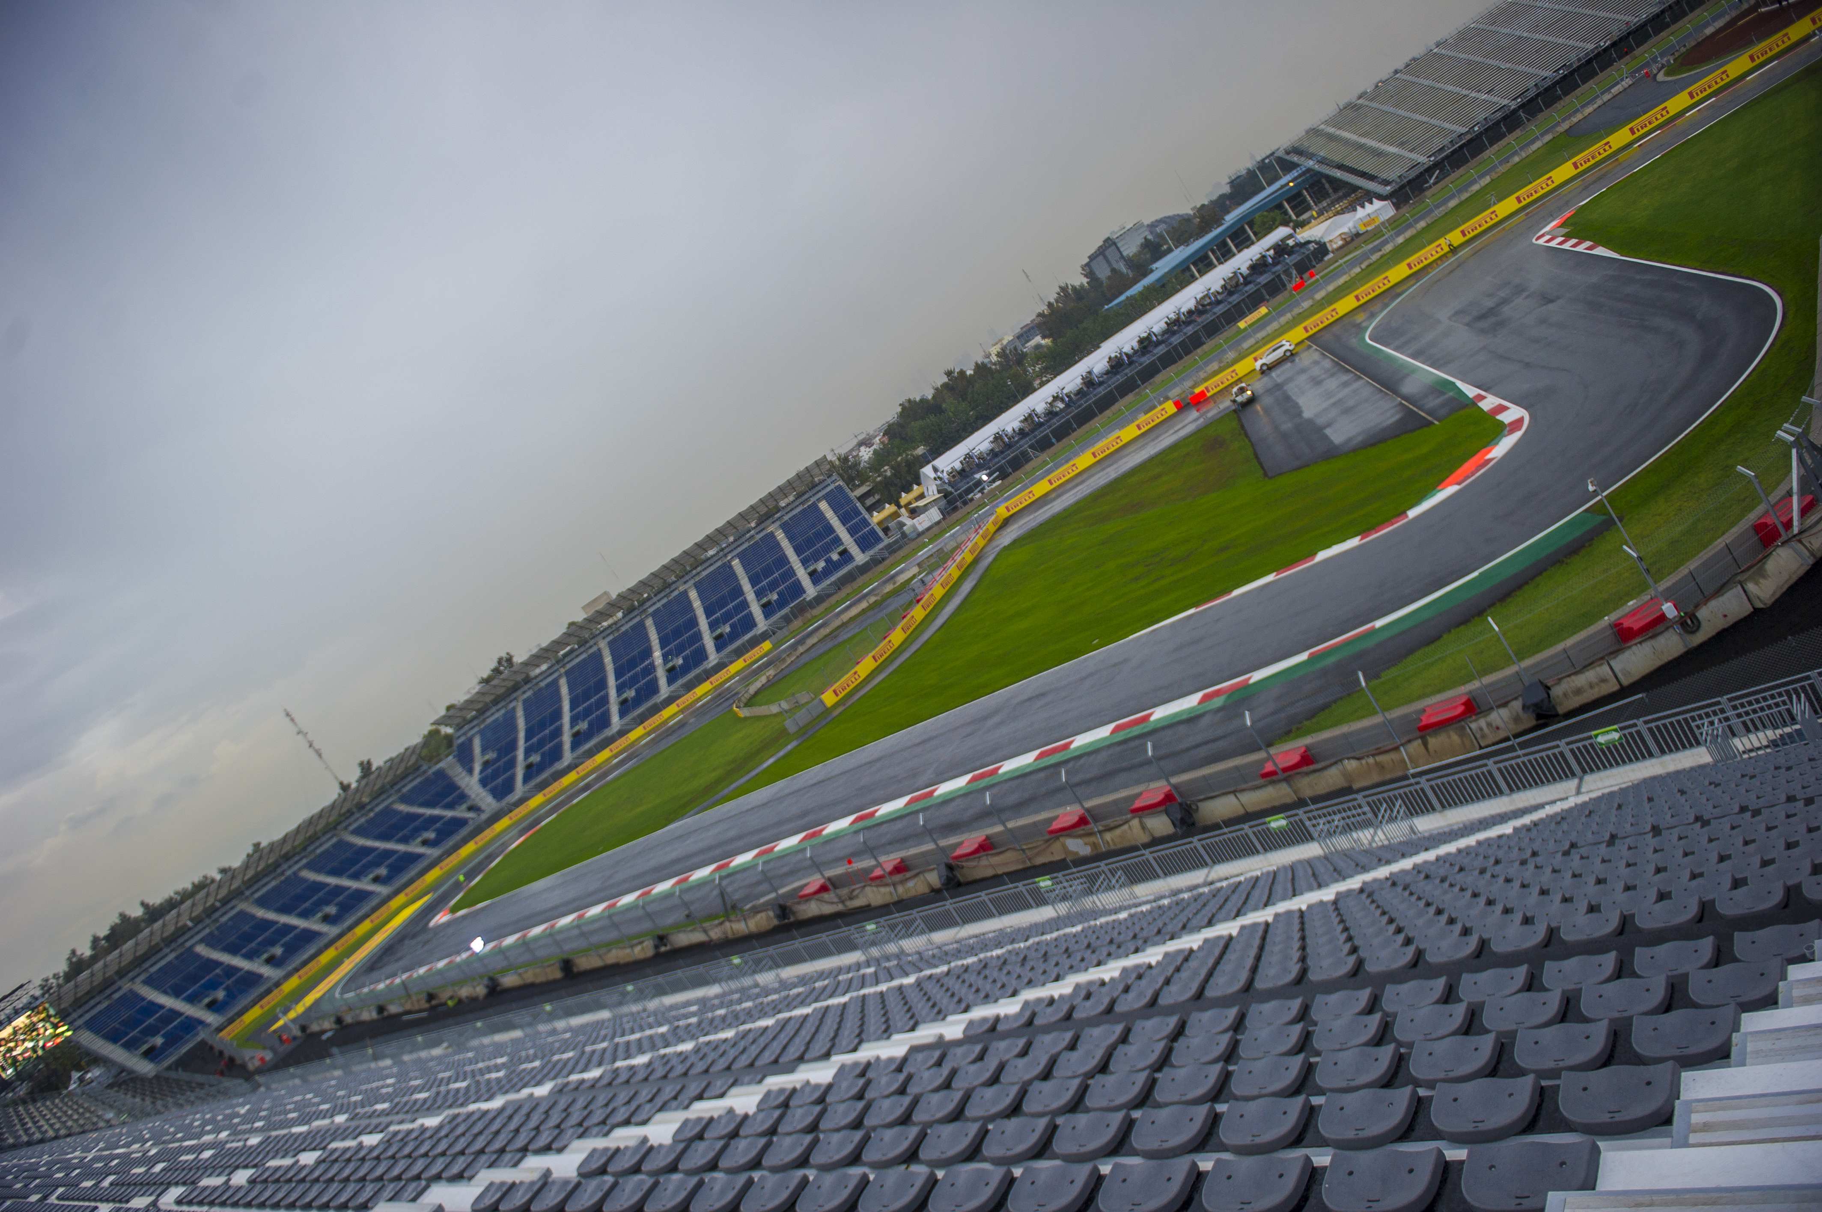

Both, teams and drivers look glad and anxious to show their racing cars power during the qualification session which will define from 1 to 10, their position on the starting grid.

We invite you to download the last pictures of the track from our Media Center on the following link: www.ahr.mx/f1/mediacenter/

Visit and Enjoy Mexico with the FORMULA 1 GRAN PREMIO DE MEXICO 2015®.

In case of further doubts please call the toll-free number 01 800 777 77 F1
www.ahr.mx
Facebook: Autódromo Hnos Rodríguez
Instagram/Twitter: @autodromohr
#MexicoGP

Contacts
Francisco Velázquez  fvelazquezc@cie.com.mx  (52 55) 52019089  CIE | Manuel Orvañanos  manuel@bandofinsiders.com  (52 55) 63866686  Band of Insiders

About CIE
Corporacion Interamericana de Entretenimiento, S.A.B de C. V.

www.cie.com.mx
We are the market leader in outdoors entertainment in Mexico, Colombia and Central America and one of the most outstanding participants in Latin America and worldwide entertainment industry.
Through a unique vertical integration model, and the only Access to an important network of entertainment centers, a base of advertisers formed by the main advertising investors in our market, as well as the alliances and strategic partnerships that we have established with experienced participants in global industry; we offer different world-class entertainment options, which include concerts, theater productions, sports, family and cultural events, among others to satisfy leisure and recreation needs for our audiences.
We operate an amusement and an aquatic park in Bogota, Colombia. Also, we commercialize the Banamex Center in Mexico City, one of the biggest and most important exhibition and convention venues internationally. In addition we are recognized as the foremost producer and organizer of special and corporative events in Mexico, and for operating one of the most professional contact centers recognized in the Mexican Market.
CIE is a public Company whose shares and debit securities are listed in the Mexican Stock Exchange.

