Mexico City, October 29, 2015

Pit Lane Walk caters to FORMULA 1 GRAN PREMIO DE MÉXICO 2015® fans
More than 2,500 die-hard Formula 1 fans were invited to the Pit Lane Walk of the FORMULA 1 GRAN PREMIO DE MÉXICO 2015® today before the circuit opened, to spend time with the drivers and teams gearing up for the Grand Prix of Mexico.
This unique experience for Formula One Paddock Club ticket holders offers visitors a unique first-hand look into the teams’ garages in the Pits.
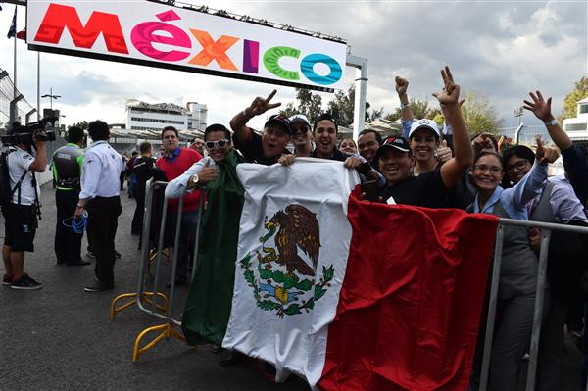 | 
The Pit Lane Walk experience ended with a taquiza, mariachis and Mexican music to welcome the Grand Prix back to Mexico after a 23-year hiatus.
Visit our Media Center at www.ahr.mx/f1/mediacenter/ to download the FORMULA 1 GRAN PREMIO DE MÉXICO 2015® Pit Lane Walk photos.



