*Mexico City, November 1, 2015*

**HALF JOKING...**

*“Could you eliminate each other so that I qualify?”* This was asked as a joke to Lewis Hamilton and Nico Rosberg in the press conference after Saturday qualification at the Autrodromo Hermanos Rodriguez, in which these couple will start on first and second place of the grid.

But, could it really happen? All week we’ve been talking about the existing frictions between Hamilton, who ensured his third world title last weekend and Rosberg, who considered the English man had been too aggressive at the beginning of the race in Texas.

Even Mercedes team said that hostility had been a key for Rosberg to get the pole position on Saturday. Will the German have enough courage to use his own strategies at the beginning of the race? Will Sebastian’s Ferrari be able to take the advantage when starting after them?

*“It’s a long way to the first curve”,* said Hamilton yesterday. In fact, there are about 800 meters from the starting grid: who knows what could happen during the first 15 seconds when the 20 cars cover that distance.

Even if Vettel can’t get to pass them on the first curve, like as a joke he said, that doesn’t mean that the German’s chances will disappear. *“I can’t predict what will happen”,* he said after qualifying, *“But we use to be stronger in the race compared to them”.*

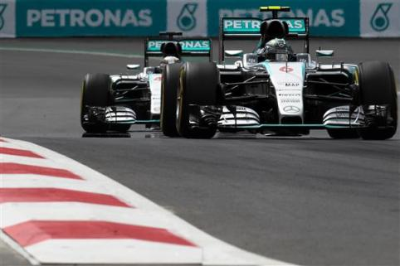

This situation has happened three times in the year —in Malaysia, Hungary and Singapore—, reason why we ask ourselves, who says it couldn’t happen for a fourth time in Mexico? Let’s not forget that Vettel has one more incentive, he is currently behind Hamilton, four points ahead from Rosberg, and want to end his first season with Ferrari in a finalist position, exceeding everyone’s expectations.

Just right after these three a young man with thirst of victory comes. DaniilKvyat has been on a par with the three-time champion and his Red Bull teammate, Daniel Ricciardo, the entire season, will he assured another podium to complement the wonderful second place he got in Hungary? Is it possible that his more experienced team mate has something to say about, and so Ricciardo starts right after the young Russian who will go out in fifth position?

23 years ago, Scudery Williams came out of Mexico after winning the last F1 race in the country. He had also won a race before, but with Valtter iBottas and Felipe Massa starting in sixth and seventh place; it doesn’t seem likely to be repeated. *“It is a shame that Red Bull are ahead of us”,* said the Finnish, *“but we have the advantage of speed on the straight, that will help when we exceed them. Overtaking is our goal for tomorrow…”*

Now well, don’t you think we have forgotten Checo Pérez who takes the ninth place on the starting grid, his first obstacle is Toro Rosso’s young man, Max Verstappen, who is one position ahead and at the same time he should beware of his most fierce rival: Nico Hulkenberg, his own team mate, who will go out next to him in the fifth row.

*“I know expectations are high”,* said Checo, who scored good punctuations on the last six races. *“However, it is a positive push. I only have to keep focused, maintain my habitual routine and thinking about tomorrow’s race as a regular one. The car is working perfectly, we have practiced and I want to move forward in the race”.*

All Mexico wants the same thing.

FORMULA 1® will undoubtedly arrive to Mexico to stay!

Visit and Enjoy Mexico with the *FORMULA 1 GRAN PREMIO DE MEXICO 2015®*

In case of further doubts please call the toll-free number 01 800 777 77 F1

[www.ahr.mx](http://www.ahr.mx/)

Facebook: Autódromo Hnos Rodríguez

Instagram/Twitter: @autodromohr

#MexicoGP

**Contacts**

|  |  |
| --- | --- |
| Francisco Velázquez  [fvelazquezc@cie.com.mx](mailto:fvelazquezc@cie.com.mx)  (52 55) 52019089  CIE | Manuel Orvañanos  [manuel@bandofinsiders.com](mailto:manuel@bandofinsiders.com),  (52 55) 63866686  Band of Insiders |

**About CIE**

Corporacion Interamericana de Entretenimiento, S.A.B de C. V.

[www.cie.com.mx](http://www.cie.com.mx/)

We are the market leader in outdoors entertainment in Mexico, Colombia and Central America and one of the most outstanding participants in Latin America and worldwide entertainment industry.

Through a unique vertical integration model, and the only Access to an important network of entertainment centers, a base of advertisers formed by the main advertising investors in our market, as well as the alliances and strategic partnerships that we have established with experienced participants in global industry; we offer different world-class entertainment options, which include concerts, theater productions, sports, family and cultural events, among others to satisfy leisure and recreation needs for our audiences.

We operate an amusement and an aquatic park in Bogota, Colombia. Also, we commercialize the Banamex Center in Mexico City, one of the biggest and most important exhibition and convention venues internationally. In addition we are recognized as the foremost producer and organizer of special and corporative events in Mexico, and for operating one of the most professional contact centers recognized in the Mexican Market.

CIE is a public Company whose shares and debit securities are listed in the Mexican Stock Exchange.