*Mexico City, October 31, 2015*

***“Always on the attack”,* Nico got the pole position, Checo will start from fifth row.**

Nico Rosberg shocked the rest of the drivers in his attempt to be the first winner of the FORMULA 1 GRAN PREMIO DE MEXICO 2015® from the century XXI and got the pole position for Mercedes, just ahead of Lewis Hamilton this afternoon at the Autodromo Hermanos Rodriguez.

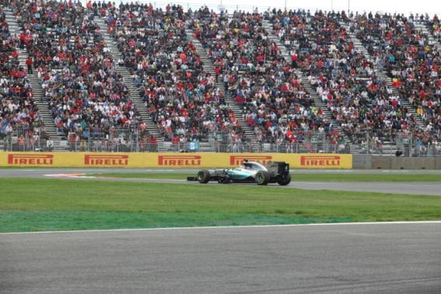

Rosberg, who is yet to recover from failure he lived in Texas, six days ago, while going out from the pit lane after Hamilton during the 12-minute final segment in the Q3, but took the lead after setting a time of 1:19.480 seconds with an average speed of 194.947 kilometers per hour to reaching the pole position for the fifth time in 2015, and the fourth consecutively.

“Always on the attack*”* Rosberg, cried happy when he was asked if this was his way to return to the battle. *‟There are still three races left and it is a great track, the usual”.*

Hamilton, who has started from the first position 11 times this season, he was able to put up a fight. Before today’s session, he published on Twitter. *‟Mexico, today is going to be a great day. It is the first F1 qualification in Mexico over 20 years. Here we go! ”*And he did it well, but not as fast as expected.

Hamilton could not improve his best time of 1:19.668, but he assured another temporay closure in first row for Mercedes. *‟Nico has been really fast this weekend”,* recognized Hamilton. *‟He has made it little by little. There were some times when the car ran wonderfully, but there are still some details to improve on my driving way and in the single-seat car.”*

Checo Perez thrilled thousands of Mexican fans when finishing among the first 10 positions, but kept everyone with the nerves to the top since he waited till the end of the Q3 to give his last boost. Finally, he got a time of 1:20.716 which was enough to place him in the ninth position, even it was on his Force India teammate’s back, Nico Hulkenberg who started by his side from the fifth row of the starting grid. The closest to the Silver Arrows was Sebastian Vettel’s Ferrari scarlet whose time set of 1:19.850 disappointed the four-time Formula 1 world champion. *‟We would have expect to finish closer, but at the end it wasn’t like that”,* admitted Vettel*.‟ I tried everything: I was happy in my first attempt in the Q3, but during the second one I think I pushed too much and couldn’t manage to improve my time”.*

Scudery Ferrari suffered a double disappointment due to a brakes problem which left Kimi Raikkonen out of Q2, only 15 minutes after having started the lap. Infinit Red Bull Racing will be happier after seeing Daniil Kvyat assuring the fourth position on the grid next to Vettel, while his teammate Daniel Ricciardo finished fifth. Williams’ Valtteri Bottas finished next to his teammate, the Australian, Felipe Massa, who finished one position after him again.

Scudery Toro Rosso’s Max Verstappen followed the same path all weekend finishing in eighth position, leaving the last two positions of the starting grid to Force India cars.

The first driver eliminated during today’s session was Jenson Button from McLaren, bue penalties even before starting qualifying laps. His teammate and also world championship Fernando Alonso, couldn’t manage to advance to Q2, so tomorrow both of them will start at the end of the grid.

¡ FORMULA 1*®* undoubtedly arrives to Mexico to stay!

*Visit and Enjoy Mexico with the FORMULA 1 GRAN PREMIO DE MEXICO 2015®.*

In case of further doubts call the toll-free number 01 800 777 77 F1

[www.ahr.mx](http://www.ahr.mx/)

Facebook: Autódromo Hnos Rodríguez

Instagram/Twitter: @autodromohr

#MexicoGP

**Contacts**

|  |  |
| --- | --- |
| Francisco Velázquez  [fvelazquezc@cie.com.mx](mailto:fvelazquezc@cie.com.mx)  (52 55) 52019089  CIE | Manuel Orvañanos  [manuel@bandofinsiders.com](mailto:manuel@bandofinsiders.com),  (52 55) 63866686  Band of Insiders |

**About CIE**

Corporacion Interamericana de Entretenimiento, S.A.B de C. V.

[www.cie.com.mx](http://www.cie.com.mx/)

We are the market leader in outdoors entertainment in Mexico, Colombia and Central America and one of the most outstanding participants in Latin America and worldwide entertainment industry.

Through a unique vertical integration model, and the only Access to an important network of entertainment centers, a base of advertisers formed by the main advertising investors in our market, as well as the alliances and strategic partnerships that we have established with experienced participants in global industry; we offer different world-class entertainment options, which include concerts, theater productions, sports, family and cultural events, among others to satisfy leisure and recreation needs for our audiences.

We operate an amusement and an aquatic park in Bogota, Colombia. Also, we commercialize the Banamex Center in Mexico City, one of the biggest and most important exhibition and convention venues internationally. In addition we are recognized as the foremost producer and organizer of special and corporative events in Mexico, and for operating one of the most professional contact centers recognized in the Mexican Market.

CIE is a public Company whose shares and debit securities are listed in the Mexican Stock Exchange.