Mexico City, November 1, 2015

Nico Rosberg gets the top of the podium in the FORMULA 1 GRAN PREMIO DE MEXICO 2015®
Checo Perez couldn’t make it to the podium but he could start Mexican fans up.
FORMULA 1 has come to Mexico to stay!
The FORMULA 1 GRAN PREMIO DE MEXICO 2015® remained captured on the history this Sunday in a fully occupied facility, with a total of 134,845 spectators, among fans, special guests and public in general. The Autodromo Hermanos Rodriguez became the track with the maximum seating capacity in the world, gathering a total of 336,174 spectators on the three-day Gran Premio de Mexico celebration, who attended the place to follow closely their favorite drivers and the Mexican Checo Perez on his first participation in the Grand Prix at home.
FORMULA 1® was felt in Mexico and rang out around the world. Fans from all over the world visited Mexico City, arriving from Friday and taking the racetrack grandstands to follow step by step all practice and qualification sessions of the FORMULA 1 GRAN PREMIO DE MEXICO 2015®.
Early today all the Access of the facility had a constant affluence, the same happened in different zones of the place, where some activities such as the F1 Game Zone, the F1 Village and concert stages were always in action and movement.
Echoes of the glorious FORMULA 1® past kept going with the victory of the British Greg Thornton on the second event of the Masters Historic Racing, who drove the Lotus 91/5 that once belonged to Elio de Angelis, while the Australian teenage, Luis Leeds, proved his talent with the victory of the F4 NACAM opening race on Sunday morning.
Just at noon, the opening began with the traditional parade of the drivers around the track, this show represented an unprecedented event in the history of FORMULA 1®, for it was led by Bernie Ecclestone, who was accompanied by Alejandro Soberon Kuri, Corporacion Interamericana de Entretenimiento (CIE) President and CEO and FORMULA 1 GRAN PREMIO DE MEXICO 2015® President, Carlos Slim Domit, America Movil CEO and Executive President and Nigel Mansell, the winning driver of the Mexican Grand Prix in 1992.
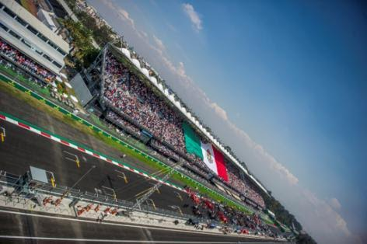
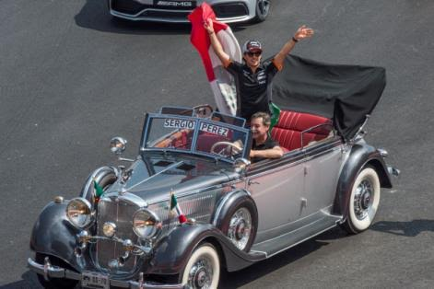
Once the parade finished, the opening gave way to the National Defense Military Band and the Guard of the Mexican Army Fusilier Skydivers Squad, followed by the interpretation of the national anthem performed by the Mixes children chorus ‘Tun"ääw kojpk"ääw’ from the locality of Oaxaca, to finish with an air display of nine planes from the Mexican Air Force leaving a green, white and red stele on his way up.
Just minutes before the 13:00 hours, drivers took their positions on the starting grid, pointed by the Grid Girls, to give way to the starting signal in order to begin with the race, where we witnessed some quarrels on the track leaving out Scudery Ferrari competitors.
After an exciting race, Nico Rosberg took the first position on the podium, followed by Lewis Hamilton, both from Mercedes and in third place finished Valtteri Bottas, from Williams. The hometown favorite, Checo Perez, managed to reach the eighth place with a pair of overruns in the section of the Foro Sol, achieving a standing ovation from all Mexican fans with motivational screams and flags, besides he was the only driver on the race to stop at the pits only once. “What a week it has been in Mexico! The vibe has been incredible and there were special moments. I am really happy of having accumulated points before my audience. I am really lucky to have my country support and I will remember this weekend forever”, Perez said.
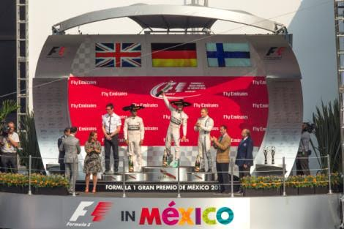
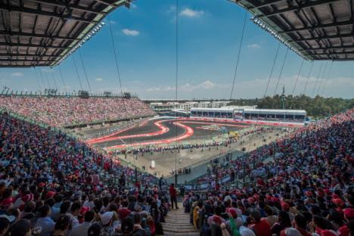
The podium of the FORMULA 1 GRAN PREMIO DE MEXICO 2015® was spectacularly lived in the zone of the Foro Sol, Nico Rosberg, Lewis Hamilton and Valtteri Botas received their trophies before thousands of fans and they were amazed with the response of the Mexican audience. "Nico completed a great race. It is fantastic to be here in Mexico. The followers feel as if they were in a football game. Fans have been incredible they have never seen something like that." Lewis Hamilton answered excited to one of the questions made by the former driver Nigel Mansell to the winners.

The award ceremony was hosted by Claudia Ruiz Massieu, Minister of Foreign Affairs, who gave the first place trophy; Alejandro Soberon Kuri, CIE President and CEO and FORMULA 1 GRAN PREMIO DE MEXICO 2015® President, who delivered the second place award, besides Horacio de la Vega, Mexico City Institute of Sports General Director (INDEPORTE), who gave the third place trophy.
To give the finishing touch to the FORMULA 1 GRAN PREMIO DE MEXICO 2015®, Mexican audience sang ‘Cielito Lindo’ at a single voice in the Foro Sol to end a historic and stirring day, to mark definitive FORMULA 1 comeback to our country.
Among celebrities and personalities that attended the event, we could meet Alejandro Fernandez, Zague, Jacqueline Bracamontes, Zuria Vega, Ana Brenda, Rodrigo Davila and Dulce Maria, to name a few.
Some of the words written on the Autodromo Hernandez Rodriguez pavement expressed it all: “F1 glad to be back in Mexico”. Nico Rosberg and Mercedes managed putting his name on the first trophy, but Mexico made FORMULA 1® world happy, and went beyond the imaginable with the Grand Prix comeback.
All Mexico is celebrating the return of motorsport top category to our country and in order to continue celebrating, the date for the next Gran Premio de Mexico was already confirmed for November 6, 2016 in the Autodromo Hermanos Rodriguez. Tickets are already on sale beginning from today with the Ticketmaster system, on the web page www.ticketmaster.com.mx, at any of the Ticketmaster Centers in Mexico, directly at ticket window number 7 of the Palacio de los Deportes in Mexico City, or calling 5325-9000, or at the Autodromo Hermanos Rodriguez official webpage www.ahr.mx.
Thank you Mexico, FORMULA 1 has come to stay!

Visit and enjoy Mexico with the FORMULA 1 GRAN PREMIO DE MEXICO 2015®.
In case of further doubts please call the toll-free number 01 800 777 77 F1
www.ahr.mx
Facebook: Autódromo Hnos Rodríguez
Instagram/Twitter: @autodromohr
#MexicoGP

Contacts
Francisco Velázquez  fvelazquezc@cie.com.mx  (52 55) 52019089  CIE | Manuel Orvañanos  manuel@bandofinsiders.com,  (52 55) 63866686  Band of Insiders

About CIE
Corporacion Interamericana de Entretenimiento, S.A.B de C. V.

www.cie.com.mx
We are the market leader in outdoors entertainment in Mexico, Colombia and Central America and one of the most outstanding participants in Latin America and worldwide entertainment industry.
Through a unique vertical integration model, and the only Access to an important network of entertainment centers, a base of advertisers formed by the main advertising investors in our market, as well as the alliances and strategic partnerships that we have established with experienced participants in global industry; we offer different world-class entertainment options, which include concerts, theater productions, sports, family and cultural events, among others to satisfy leisure and recreation needs for our audiences.
We operate an amusement and an aquatic park in Bogota, Colombia. Also, we commercialize the Banamex Center in Mexico City, one of the biggest and most important exhibition and convention venues internationally. In addition we are recognized as the foremost producer and organizer of special and corporative events in Mexico, and for operating one of the most professional contact centers recognized in the Mexican Market.
CIE is a public Company whose shares and debit securities are listed in the Mexican Stock Exchange.

