Mexico City, April 28th, 2016.

Formula 1 Gran Premio de Mexico® and Road Safety Drivers celebrates “Children’s Day”.
Besides, deaf children –silently- enjoyed Formula 1®’s party.

Due to “Children’s Day” proximity and as a part of FORMULA 1 GRAN PREMIO DE MÉXICO® social responsibility actions, in coordination with Road Safety Drivers, they all attended Gokartmania 50 boys and girls from the Pedagogical Institute for Language Problems, IPPLIAP, institution who has been focused for the last 49 years to educate children and teenagers who are deaf or have any language and learning problems.
The event was also attended by the Tractor driver Gisela Ponce, member of Road Safety Drivers, who taught children the Road Safety Decalogue helped by some explanatory videos.
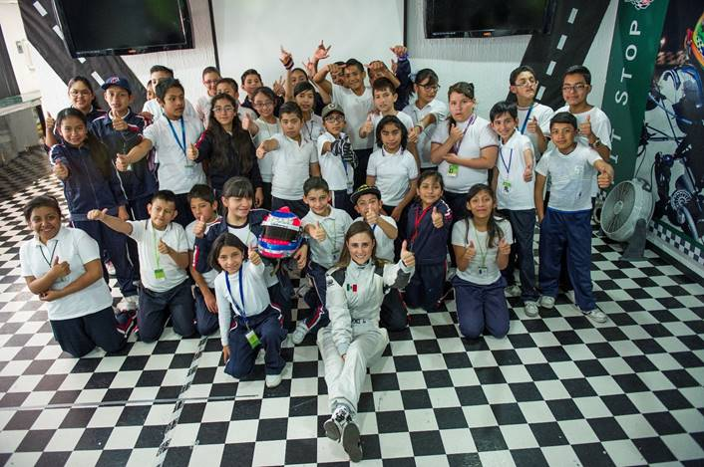

The students which come from low-income families followed closely Gisela, who comes from an important dynasty of drivers; daughter of Javier Ponce Guzman, a well-known driver from the 70’s, 80’s and 90’s. She also explained the importance of safety belt use and the risks of distractions, such as the cell phone. An interpreter from Ippliap, simultaneously translated the explanation in sign language. They could also watch a video with a resemblance of FORMULA 1 GRAN PREMIO DE MEXICO® history, where they could feel the vibration of the blaring cars engines and the music on the speakers, to “vibrate” the excitement of the pinnacle of motorsport category.

Besides having important achievements in the tractor category, Gisela has also won different awards for her both, athletic and academic performance, most of all for her social responsibility, which is why she became spokesperson of these lectures that will be carried out regularly in different academic institutions aimed at elementary, secondary, high school and universities.

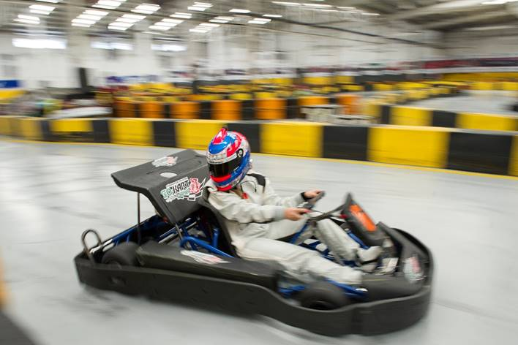

At the end of the lecture, the children received another surprise, since they were also expected by driver Pepe Montaño, who has been a professional driver for 27 years for tourism, formula, cars Nascar cars and nowadays in the Super V8 category. Pepe, BMW Driver training’s official driver, who is also in charge of the only Sport Driving School that uses Formula cars, organized a go karts race with Ippliap children. The first three positions of each category took the winner’s podium to receive a FORMULA 1 GRAN PREMIO DE MEXICO® cap, the winners’ medal, and of course the traditional celebration couldn’t be missed, this time with mineral water bottles.

Besides the visit of Ippliap to Gokartmania, these lectures organized by the FORMULA 1 GRAN PREMIO DE MEXICO® were carried out in schools Avante and Giocosa, in this last school they also received the visit of driver Andres Orea, who has participated in karting, cycling and motorcycling, tourism and resistance cars, being a novice of the year in the Super Copa Telcel 2012 and champion of the Copa Pro Mothers in 2015.

THE FORMULA 1 GRAN PREMIO DE MEXICO® gave away a box of candies for children to celebrate their day, a coloring book and badge of “Ambassadors of Safety Road”. THE FORMULA 1 GRAN PREMIO DE MEXICO® will keep taking these social actions along different public and private schools for all levels including visits to universities.
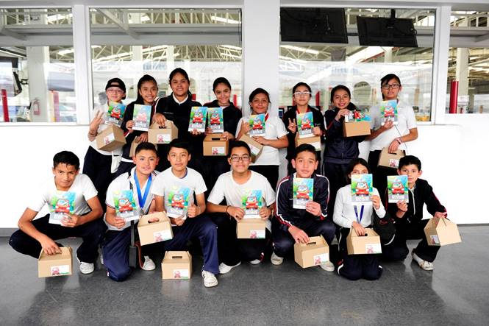
You still can find available tickets don’t miss the FORMULA 1 GRAN PREMIO DE MEXICO 2016.
Tickets are on sale through the Ticketmaster Net on the webpage www.ticketmaster.com.mx, Ticketmaster authorized centers, calling 5325 9000 or at the ticket window no. 7 placed in Palacio de los Deportes.
Find more information about the location of your tickets on www.mexicogp.mx
Corporate Packs available with:
Diego Pérez
dperez@cie.com.mx

www.mexicogp.mx
Facebook: mexicogp
Instagram/Twitter: @mexicogp
#MexicoGP #F1ESTA
Contacts Press
Francisco Velazquez Manuel Orvañanos
fvelazquezc@cie.com.mx Manuel@bandofinsiders.com
(52 55) 52019089 (52 55) 63.86.66.86

About CIE
Corporacion Interamericana de Entretenimiento, S.A.B de C. V.
www.cie.com.mx
We are the market leader in outdoors entertainment in Mexico, Colombia and Central America and one of the most outstanding participants in Latin America and worldwide entertainment industry.
Through a unique vertical integration model, and the only Access to an important network of entertainment centers, a base of advertisers formed by the main advertising investors in our market, as well as the alliances and strategic partnerships that we have established with experienced participants in global industry; we offer different world-class entertainment options, which include concerts, theater productions, sports, family and cultural events, among others to satisfy leisure and recreation needs for our audiences.
We operate an amusement and an aquatic park in Bogota, Colombia. Also, we commercialize the Banamex Center in Mexico City, one of the biggest and most important exhibition and convention venues internationally. In addition we are recognized as the foremost producer and organizer of special and corporative events in Mexico, and for operating one of the most professional contact centers recognized in the Mexican Market.
CIE is a public Company whose shares and debit securities are listed in the Mexican Stock Exchange.

