Mexico City, May 4th, 2016
What to expect from Formula 1® as a Speed Lover (blue /orange zone)?
If you love speed and want to enjoy all possible records and the sound produced by the cars engines on the straight of the renewed Autodromo Hermanos Rodriguez, the complex Moises Solana or on the short straight, then you are a Speed Lover. Why?
Zones blue and orange for the Speed Lover profile are specially designed for the attendees to identify the best way to enjoy the race, according to their preferences. This profile is provided with different grandstands around the circuit in one of the fastest FORMULA 1® tracks, here you’ll be able to enjoy cars passing by the zone where the speed record of season 2015 was broken with 366.4 km/h, witnessing cars pass-by at full speed, the braking before entering the complex Moises Solana and its way out towards The Stadium.
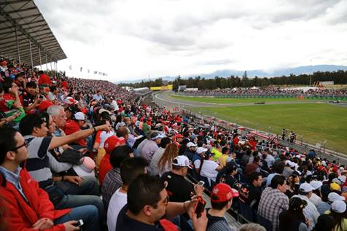
Witnesses FORMULA 1 GRAN PREMIO DE MEXICO 2015®
Eddy Vilard
“Being able to enjoy that zone during the historical return of FORMULA 1® to our country was incredible, I could experience the adrenaline emitted by the cars and being witness of the speed record imposed by Pastor Maldonado during the race, I would definitely return the same place for the incoming race in Mexico” Renato Lopez
“Being able to choose your favorite zone for the race with the proper information is a huge advantage, the circuits offer different kind of attractions, for those who love to experience the full speed and for those who prefer a more technical zone for each track, the important thing to know is what to expect from each of the zones so you can take a full advantage of your ticket”.
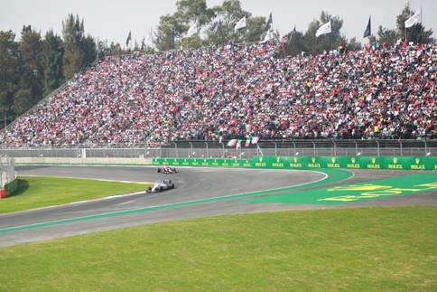
The blue zone for the Speed Lover profile still has some available seats on grandstands 3A, 3, 4, 5, 6 and 6A. Do not miss the opportunity of first-hand living FORMULA 1® cars speed.
Click on the link bellow to view grandstand 3:
http://espeditour.com/360s/CIE/3?utm_source=Boletin&utm_medium=Vista360_Grada_3&utm_content=Trafico_Sitio&utm_campaign=F1_abril_360
Click on the link bellow to view grandstand 4:
http://espeditour.com/360s/CIE/4?utm_source=Boletin&utm_medium=Vista360_Grada_4&utm_content=Trafico_Sitio&utm_campaign=F1_abril_360
Click on the link bellow to view grandstand 5:
http://espeditour.com/360s/CIE/5?utm_source=Boletin&utm_medium=Vista360_Grada_5&utm_content=Trafico_Sitio&utm_campaign=F1_abril_360
Click on the link bellow to view grandstand 6:
http://espeditour.com/360s/CIE/6?utm_source=Boletin&utm_medium=Vista360_Grada_6&utm_content=Trafico_Sitio&utm_campaign=F1_abril_360
Click on the link below to view grandstand 6A:
http://espeditour.com/360s/CIE/6A?utm_source=Boletin&utm_medium=Vista360_Grada_6A&utm_content=Trafico_Sitio&utm_campaign=F1_abril_360
The orange zone with the Speed Lover profile was the very first to sell out its seats for the FORMULA 1 GRAN PREMIO DE MEXICO 2016®, fans who have a ticket for grandstand 2A, will be able to live the full experience next October 28, 29 and 30 at the Autodromo Hermanos Rodriguez.
Click on the link bellow to view grandstand 2A:
http://espeditour.com/360s/CIE/2A?utm_source=Boletin&utm_medium=Vista360_Grada_2A&utm_content=Trafico_Sitio&utm_campaign=F1_abril_360

If you haven’t defined your profile, remember it responds to what you would like to enjoy the most of the FORMULA 1 GRAN PREMIO DE MEXICO 2016®, according to that, choose what kind of fan you are or which your profile is. The following step would be choosing the grandstand you prefer, your seat and getting your tickets.
Tickets are still available, do not miss the FORMULA 1 GRAN PREMIO DE MÉXICO 2016®.
Tickets are on sale through the Ticketmaster Network on the web page www.ticketmaster.com.mx, Ticketmaster authorized centers, calling 5325 9000 or at the ticket window no. 7 placed in Palacio de los Deportes.
Find more information about the location of your tickets on the webpage www.mexicogp.mx
Corporative packs available at:
Diego Perez
dperez@cie.com.mx

www.mexicogp.mx
Facebook: mexicogp
Instagram/Twitter: @mexicogp
#MexicoGP #F1ESTA

Contact:
Francisco Velazquez  fvelazquezc@cie.com.mx  (52 55) 52019089  CIE | Manuel Orvañanos  manuel@bandofinsiders.com  (52 55) 63866686  Band of Insiders
About CIE
Corporacion Interamericana de Entretenimiento, S.A.B de C. V.
www.cie.com.mx
We are the market leader in outdoors entertainment in Mexico, Colombia and Central America and one of the most outstanding participants in Latin America and worldwide entertainment industry.
Through a unique vertical integration model, and the only Access to an important network of entertainment centers, a base of advertisers formed by the main advertising investors in our market, as well as the alliances and strategic partnerships that we have established with experienced participants in global industry; we offer different world-class entertainment options, which include concerts, theater productions, sports, family and cultural events, among others to satisfy leisure and recreation needs for our audiences.
We operate an amusement and an aquatic park in Bogota, Colombia. Also, we commercialize the Banamex Center in Mexico City, one of the biggest and most important exhibition and convention venues internationally. In addition we are recognized as the foremost producer and organizer of special and corporative events in Mexico, and for operating one of the most professional contact centers recognized in the Mexican Market.
CIE is a public Company whose shares and debit securities are listed in the Mexican Stock Exchange.

