*Mexico City, May 12th, 2016*

**Checo Perez and Blue Demon Jr. “wrestle” in Barcelona**

Six months away from the beginning of FORMULA 1 GRAN PREMIO DE MEXICO 2016®, the iconic wrestler Blue Demon Jr. and Sergio “Checo” Perez, from team Sahara Force India, met for a series of activities in which both of them showed their skills in their corresponding areas of experience within the celebration of the Gran Premio de Barcelona.

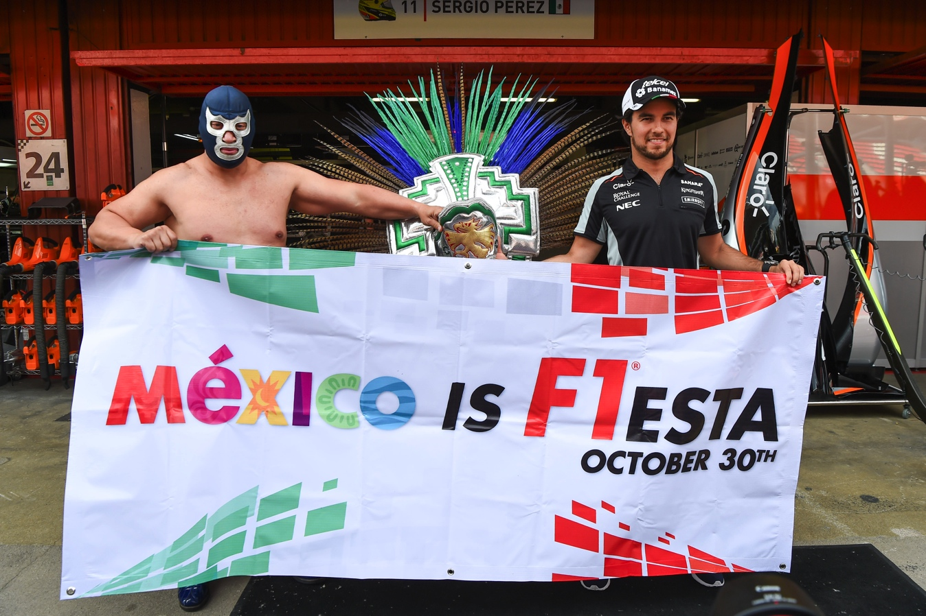

The promoter of the Mexican #F1ESTA, CIE (Corporacion Interamericana de Entretenimiento), created a strategic Alliance with AAA, Worldwide Wrestling in order to take advantage of the Gran Premio de Mexico’s success and maximize the promotion of the event for this year.

“It was amazing to see “Checo” in his racing environment. I have followed his career for the last couple of years and not only is a fantastic representative for LA FORMULA 1® in Mexico, but also an ambassador of Mexican Sport around the world. Besides, we both feel a huge pride for our country, same that we were able to share today”, said Blue Demon Jr.

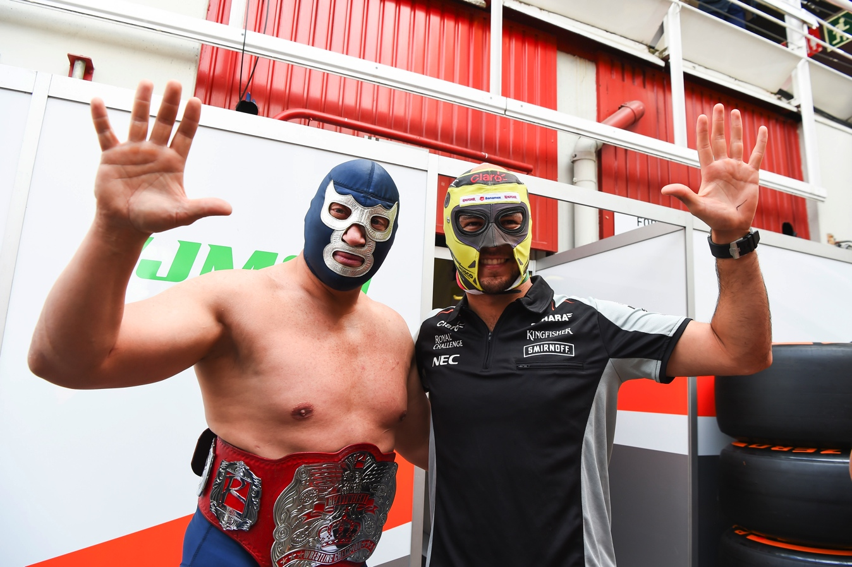

Surrounded by journalists from all around the world, “Checo” and Blue Demon Jr. conveyed their Mexican passion for the entire track of the Catalan Capital, reminding the world, the indescribable energy that was lived during the FORMULA 1 GRAN PREMIO DE MEXICO 2015®.

Rodrigo Sanchez, FORMULA 1 GRAN PREMIO DE MEXICO®, Marketing and Public Relations Director, said: “Leaving soccer aside, wrestling is the sport with the largest number of fans in Mexico. Just like the wrestling, motor sports have an important legacy in our country and we are really keen to continue building a forum more attractive for a much younger and a different audience. Working with an association like the AAA has let us to reach a new audience”.

On the other hand, Sergio Perez, driver for Sahara Force India team, stated: “It has been really fun to show Blue Demon Jr. the garage, the paddock and the track. This was a great opportunity to show the other side of Mexican sports culture, and with that the perception of Mexico will go beyond than just a beach, food or tequila. We are a country of traditions and passion for sports and thanks to this visit, the desire of competing again this year in the Autodromo Hermanos Rodriguez came back to me. There is no other audience in any part of the world better than Mexican”.

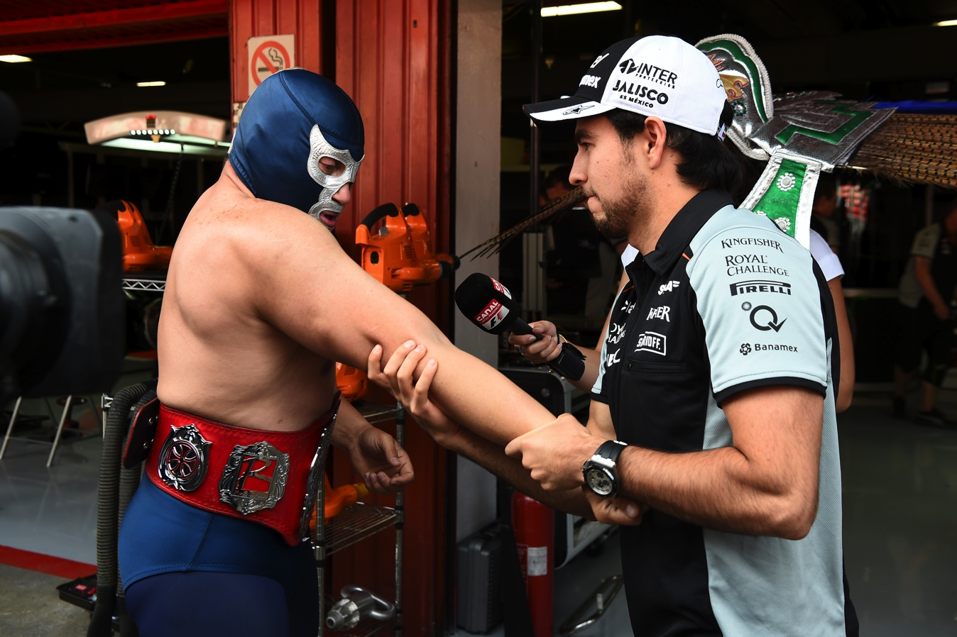

Finally, Dorian Roldan, AAA Executive Vice President, said: “We are really proud of our partnership with FORMULA 1 GRAN PREMIO DE MEXICO®. Both sports complement each other very well and we would like to welcome the opportunity to reinforce both the sporting heritage of Mexico and our position as one of the most popular national sports. Mexican wrestling is an essential part of the sport identity in Mexico and our athletes are looking forward to meeting F1 drivers and learn more about this sport. It is without a doubt and honor to be involved in this kind of events”.

The dynamics held in Spain, the fifth round of the season in FoFORMULA 1®, is the first of several promotional activities scheduled throughout the year, towards the race of October 30th at the Autodromo Hermanos Rodriguez.

Tickets are still available, do not miss the FORMULA 1 GRAN PREMIO DE MÉXICO 2016®.Tickets are on sale through the Ticketmaster Network on the web page www.ticketmaster.com.mx, Ticketmaster authorized centers, calling 5325 9000 or at the ticket window no. 7 placed in Palacio de los Deportes.

Find more information about tickets on the webpage [www.mexicogp.mx](http://www.mexicogp.mx).

Corporative packs available at:

Diego Perez

[dperez@cie.com.mx](mailto:dperez@cie.com.mx)

-or-

[www.mexicogp.mx](http://www.mexicogp.mx/)

Facebook: mexicogp

Instagram/Twitter: @mexicogp

#MexicoGP #F1ESTA

**Contact:**

|  |  |  |
| --- | --- | --- |
| Francisco Velázquez  [fvelazquezc@cie.com.mx](mailto:fvelazquezc@cie.com.mx)  (52 55) 52019089  CIE |  | Manuel Orvañanos  [manuel@bandofinsiders.com](mailto:manuel@bandofinsiders.com)  (52 55) 63866686  Band of Insiders |

**About CIE**

Corporacion Interamericana de Entretenimiento, S.A.B de C. V.

[www.cie.com.mx](http://www.cie.com.mx/)

We are the market leader in outdoor entertainment in Mexico, Colombia and Central America and one of the major players in the entertainment industry in Latin America and across the globe.

CIE offers a variety of world-class entertainment options including concerts, theater productions, and sports and family and cultural events, among others, to meet our market segments’ needs for recreation and entertainment through its unique vertical integration model that provides the only access available to an extensive network of entertainment centers, advertisers including the principal advertising investors in our markets, and partnerships and strategic alliances with experienced global partners.

We operate an amusement and water park in Bogota, Colombia, and manage Centro Banamex in Mexico City, one of the largest convention and exhibition facilities across the globe. We are recognized as the foremost producer and organizer of special and corporate events in Mexico, and we operate one of the most professional contact centers in the Mexican market.

CIE is a public company whose shares and debt securities are listed on the Mexican Stock Exchange.