|  |
| --- |
|  |

*Mexico City, August, 19th, 2016*

**A few days to finish the Olympic Games, we present you the podium journal of the Formula 1**

The summer fair is coming to its end, little by little you begins to close the final number of victories awarded by country and by athlete of the Olympic Games. With this in mind, here we present the podiums highlights of the Formula 1 heading for the Grand Prix of Mexico 2016.



****

**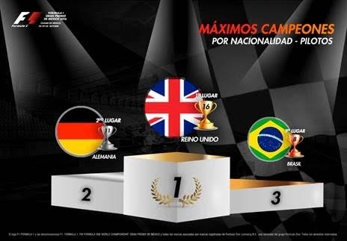**

****

-or-

[www.mexicogp.mx](http://www.mexicogp.mx/)

Facebook: mexicogp

Instagram/Twitter: @mexicogp

#MexicoGP #F1ESTA

**Contact:**

|  |  |
| --- | --- |
| Francisco Velazquez  [fvelazquezc@cie.com.mx](mailto:fvelazquezc@cie.com.mx)  (52 55) 52019089  CIE | Manuel Orvañanos  [manuel@bandofinsiders.com](mailto:manuel@bandofinsiders.com)  (52 55) 63866686  Band of Insiders |

**About CIE**

Corporacion Interamericana de Entretenimiento, S.A.B de C. V.

[www.cie.com.mx](http://www.cie.com.mx/" \t "_blank)

We are the market leader in outdoor entertainment in Mexico, Colombia and Central America and one of the major players in the entertainment industry in Latin America and across the globe.

CIE offers a variety of world-class entertainment options including concerts, theater productions, and sports and family and cultural events, among others, to meet our market segments’ needs for recreation and entertainment through its unique vertical integration model that provides the only access available to an extensive network of entertainment centers, advertisers including the principal advertising investors in our markets, and partnerships and strategic alliances with experienced global partners.

We operate an amusement and water park in Bogota, Colombia, and manage Centro Banamex in Mexico City, one of the largest convention and exhibition facilities across the globe. We are recognized as the foremost producer and organizer of special and corporate events in Mexico, and we operate one of the most professional contact centers in the Mexican market.

CIE is a public company whose shares and debt securities are listed on the Mexican Stock Exchange.