Mexico City, September 20, 2016

Adrian Fernandez joins to the F1ESTA of FORMULA 1 GRAN PREMIO DE MEXICO™ as the official ambassador.

o The Mexican former driver was appointed as ambassador of the F1ESTA in Mexico.
To honor his successful career, with the nomination of a curve of the Autodromo Hermanos Rodriguez named after him.
As a gesture of appreciation for his influence in National Motor racing, and for being an inspiration for younger generation, Corporacion Interamericana de Entretenimiento (CIE) –FORMULA 1 GRAN PREMIO DE MÉXICO™ official promoter– officially named the Mexican former driver, Adrian Fernandez, ambassador for the event that will take place from October 28 to October 30.

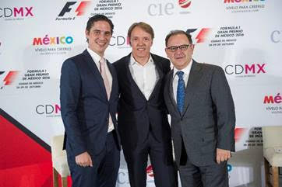
“There is definitely no need to explain the importance of Adrian in the history of Mexican Motor racing, or the reasons behind our decision to name him friend and ambassador of our event. However, it is important to remember his career and his achievements” stated Federico Gonzalez Compean, FORMULA 1 GRAN PREMIO DE MEXICO™ chief executive.

To the effect of celebration and tribute of the nomination of the Mexican driver, the curve 12 of the Autodromo Hermanos Rodriguez was also revealed – it is placed at the entrance of the Foro Sol complex – it will be renamed from now on as Adrian Fernandez Curve in honor of the iconic driver.

“It is such a great honor to be nominated as official ambassador of the FORMULA 1 GRAN PREMIO DE MEXICO 2016™. It gets me excited to be seen as spokesman of the highest category of motor racing after his historic comeback to our country”, said Fernandez. “As a driver I lived unforgettable moments in this racetrack, which is why having a curve named after me is an incomparable feeling. It is something that would make feel anyone in this field very satisfied and happy. I am very grateful”, he said.
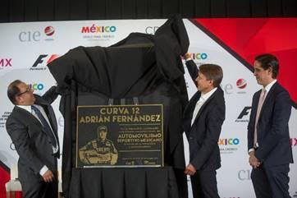

Since the 90’s, Adrian Fernandez has been one of the Mexican drivers most recognized of all times thanks to his outstanding achievements in CART and IRL, where he accumulated 14 victories. In these categories he got the runner-up in the year 2000 and won four of them with his own team, ‘Fernandez Racing’, a feat that no other Mexican driver has ever reached.

Besides winning the title of LMP2 (Le Mans Prototype) in the American Le Mans with Luis Diaz aboard a Fernandez Racing in 2009, his record is formed by a successful pass through the 24-Hour Le Mans, NASCAR Busch Series, Grand Am, Formula 3, Indy Lights and Formula K to name a few.

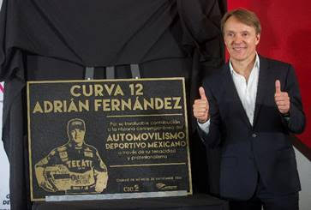

Soon we will reveal more details about his work as ambassador that will surely include presentations at the Autodromo Hermanos Rodriguez during the FORMULA 1 GRAN PREMIO DE MEXICO 2016™ where he will socialize with his fans.

Do not miss the FORMULA 1 GRAN PREMIO DE MEXICO 2016™!

Last tickets are still available on sale Ticketmaster though the Ticketmaster Network, on the webpage www.ticketmaster.com.mx, Authorized Ticketmaster Centers, calling 5325 9000 or at the ticket window no. 7 placed in Palacio de los Deportes.

Look for further information at www.mexicogp.mx.
Facebook: mexicogp
Instagram/Twitter: @mexicogp
#MexicoGP #F1ESTA #F1EBRE

Contact

Francisco Velazquez  fvelazquezc@cie.com.mx  (52 55) 52019089  CIE | Manuel Orvañanos  manuel@bandofinsiders.com  (52 55) 63866686  Band of Insiders

About CIE
Corporacion Interamericana de Entretenimiento, S.A.B de C. V.
www.cie.com.mx
We are the market leader in outdoor entertainment in Mexico, Colombia and Central America and one of the major players in the entertainment industry in Latin America and across the globe.

CIE offers a variety of world-class entertainment options including concerts, theater productions, and sports and family and cultural events, among others, to meet our market segments’ needs for recreation and entertainment through its unique vertical integration model that provides the only access available to an extensive network of entertainment centers, advertisers including the principal advertising investors in our markets, and partnerships and strategic alliances with experienced global partners.

We operate an amusement and water park in Bogota, Colombia, and manage Centro Banamex in Mexico City, one of the largest convention and exhibition facilities across the globe. We are recognized as the foremost producer and organizer of special and corporate events in Mexico, and we operate one of the most professional contact centers in the Mexican market.

CIE is a public company whose shares and debt securities are listed on the Mexican Stock Exchange.

