*Mexico City, 21 October, 2016*

**Fun beyond the track at the**

**FORMULA 1 GRAN PREMIO DE MEXICO 2016™**

At the FORMULA 1 GRAN PREMIO DE MEXICO 2016™ the entertainment is not only on the track, but also around it. This year throughout the three days of event, attendants will enjoy a wide offer of additional activities to have fun for hours in this F1ESTA.

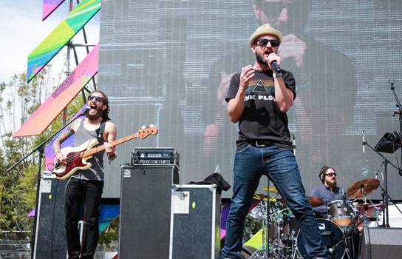

**F1 Village.**

It is comprised by over 20,000 square meters of space and it is the ideal place to buy *souvenirs*, here they will find FORMULA 1 GRAN PREMIO DE MÉXICO 2016™ and team’s official merchandise. Among the items on sale we will find caps, t-shirts, key rings and other curiosities.

**F1 Game Zone.**

The whole family will have a great *off-track* time, at this interactive entertainment center where to measure your skills in front of other fans. At this place there are Formula 1® cars’ simulators which are interconnected to set a virtual tournament among the fans *.

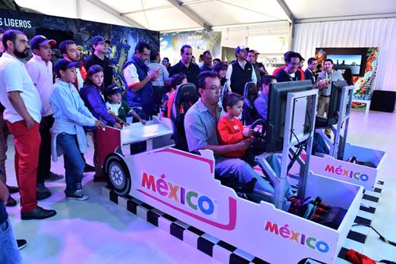

|  |  |  |  |  |  |  |  |  |  |  |  |  |  |  |  |  |  |  |  |  |  |  |  |  |  |  |  |  |  |  |  |  |  |  |  |  |  |  |  |  |  |  |  |  |  |  |  |  |  |  |  |  |  |  |  |  |  |  |  |  |  |  |  |  |  |  |  |  |  |  |  |  |  |  |  |  |  |  |  |  |  |  |  |  |  |  |  |  |  |  |  |  |  |  |  |  |  |  |  |  |  |  |  |  |  |  |  |  |  |  |  |  |  |  |  |  |  |  |  |  |  |  |  |  |  |  |  |  |  |  |  |  |  |  |  |  |  |  |  |  |  |  |  |  |  |  |  |  |  |  |  |  |  |  |  |  |  |  |  |  |  |  |  |  |  |  |  |  |  |  |  |  |  |  |  |  |  |  |  |  |  |  |  |  |  |  |  |  |  |  |  |  |  |  |  |  |  |  |  |  |  |  |  |  |  |  |  |  |  |  |  |  |  |  |  |  |  |  |  |  |  |  |  |  |  |  |  |  |  |  |  |  |  |  |  |
| --- | --- | --- | --- | --- | --- | --- | --- | --- | --- | --- | --- | --- | --- | --- | --- | --- | --- | --- | --- | --- | --- | --- | --- | --- | --- | --- | --- | --- | --- | --- | --- | --- | --- | --- | --- | --- | --- | --- | --- | --- | --- | --- | --- | --- | --- | --- | --- | --- | --- | --- | --- | --- | --- | --- | --- | --- | --- | --- | --- | --- | --- | --- | --- | --- | --- | --- | --- | --- | --- | --- | --- | --- | --- | --- | --- | --- | --- | --- | --- | --- | --- | --- | --- | --- | --- | --- | --- | --- | --- | --- | --- | --- | --- | --- | --- | --- | --- | --- | --- | --- | --- | --- | --- | --- | --- | --- | --- | --- | --- | --- | --- | --- | --- | --- | --- | --- | --- | --- | --- | --- | --- | --- | --- | --- | --- | --- | --- | --- | --- | --- | --- | --- | --- | --- | --- | --- | --- | --- | --- | --- | --- | --- | --- | --- | --- | --- | --- | --- | --- | --- | --- | --- | --- | --- | --- | --- | --- | --- | --- | --- | --- | --- | --- | --- | --- | --- | --- | --- | --- | --- | --- | --- | --- | --- | --- | --- | --- | --- | --- | --- | --- | --- | --- | --- | --- | --- | --- | --- | --- | --- | --- | --- | --- | --- | --- | --- | --- | --- | --- | --- | --- | --- | --- | --- | --- | --- | --- | --- | --- | --- | --- | --- | --- | --- | --- | --- | --- | --- | --- | --- | --- | --- | --- | --- | --- | --- | --- | --- | --- | --- | --- | --- | --- | --- | --- |
| |  |  |  |  |  |  |  |  |  |  |  |  |  |  |  |  |  |  |  |  |  |  |  |  |  |  |  |  |  |  |  |  |  |  |  |  |  |  |  |  |  |  |  |  |  |  |  |  |  |  |  |  |  |  |  |  |  |  |  |  |  |  |  |  |  |  |  |  |  |  |  |  |  |  |  |  |  |  |  |  |  |  |  |  |  |  |  |  |  |  |  |  |  |  |  |  |  |  |  |  |  |  |  |  |  |  |  |  |  |  |  |  |  |  |  |  |  |  |  |  |  |  |  |  |  |  |  |  |  |  |  |  |  |  |  |  |  |  |  |  |  |  |  |  |  |  |  |  |  |  |  |  |  |  |  |  |  |  |  |  |  |  |  |  |  |  |  |  |  |  |  |  |  |  |  |  |  |  |  |  |  |  |  |  |  |  |  |  |  |  |  |  |  |  |  |  |  |  |  |  |  |  |  |  |  |  |  |  |  |  |  |  |  |  |  |  |  |  |  |  |  |  |  |  |  |  |  |  |  |  |  |  |  |  |  | | --- | --- | --- | --- | --- | --- | --- | --- | --- | --- | --- | --- | --- | --- | --- | --- | --- | --- | --- | --- | --- | --- | --- | --- | --- | --- | --- | --- | --- | --- | --- | --- | --- | --- | --- | --- | --- | --- | --- | --- | --- | --- | --- | --- | --- | --- | --- | --- | --- | --- | --- | --- | --- | --- | --- | --- | --- | --- | --- | --- | --- | --- | --- | --- | --- | --- | --- | --- | --- | --- | --- | --- | --- | --- | --- | --- | --- | --- | --- | --- | --- | --- | --- | --- | --- | --- | --- | --- | --- | --- | --- | --- | --- | --- | --- | --- | --- | --- | --- | --- | --- | --- | --- | --- | --- | --- | --- | --- | --- | --- | --- | --- | --- | --- | --- | --- | --- | --- | --- | --- | --- | --- | --- | --- | --- | --- | --- | --- | --- | --- | --- | --- | --- | --- | --- | --- | --- | --- | --- | --- | --- | --- | --- | --- | --- | --- | --- | --- | --- | --- | --- | --- | --- | --- | --- | --- | --- | --- | --- | --- | --- | --- | --- | --- | --- | --- | --- | --- | --- | --- | --- | --- | --- | --- | --- | --- | --- | --- | --- | --- | --- | --- | --- | --- | --- | --- | --- | --- | --- | --- | --- | --- | --- | --- | --- | --- | --- | --- | --- | --- | --- | --- | --- | --- | --- | --- | --- | --- | --- | --- | --- | --- | --- | --- | --- | --- | --- | --- | --- | --- | --- | --- | --- | --- | --- | --- | --- | --- | --- | --- | --- | --- | --- | --- | --- | | **Stages.**  Around the Autodromo Hermanos Rodriguez complex there are five different stages to enjoy a great variety of live bands – with different music styles throughout the three days of event–besides autograph session with FORMULA 1 GRAN PREMIO DE MÉXICO 2016™’s official ambassadors: Emerson Fittipaldi and Adrian Fernandez.    Concerts’ line-up include the participation of bands like *Help*– a recognized band of Beatles’ covers–, the cover band *Heels on Fire* – a ‘rockabilly’ style show –, *Samsons* –also with original songs–, *James –pop music–*, *Five Fingers* –rock in Spanish and English, as well as the originals *Rumberos de Massachusetts*.    Three-day event activities’ time table:   |  |  |  |  |  |  |  |  |  | | --- | --- | --- | --- | --- | --- | --- | --- | --- | | **MUSICAL ACTIVITIES ON STAGE** | | | | | | | | | | Friday, 28 October | | |  | Saturday, 29 October | |  | Sunday, 30 October | | | Schedule | | Artist |  | Schedule | Artist |  | Schedule | Artist | | GREEN ZONE | | |  | GREEN ZONE | |  | GREEN ZONE | | | 10:00  13:00 | DJ | |  | 09:30 11:30 | DJ |  | 09:30 11:00 | DJ | | 11:30  12:30 | AMBASSADORS AUTOGRAPH SESSION | |  | 11:30 13:00 | SAMSONS |  | 10:30 11:30 | AMBASSADORS AUTOGRAPH SESSION | | 13:00  15:00 | LEMARROY | |  | 14:00  15:30 | HEELS ON FIRE |  | 11:30  13:00 | JAMES | | 16:00  19:00 | DJ | |  | 16:00 18:00 | SAM KOEN |  | 15:00 16:30 | FIVE FINGERS | |  |  | |  |  |  |  | 16:30 18:00 | LEMARROY | | ORANGE ZONE | | |  | ORANGE ZONE | |  | ORANGE ZONE | | | 10:00  13:00 | DJ | |  | 11:30 13:00 | DJ |  | 10:00 13:00 | DJ | | 13:00  15:00 | SAM KOEN | |  | 14:00 15:30 | DJ |  | 15:00 17:30 | DJ | | 15:00  18:00 | DJ | |  | 16:00 18:00 | MAUMOCTEZUMA |  | 17:30 20:00 | CÉSAR CARRILLO | | BLUE ZONE/  F1 VILLAGE | | |  | BLUE ZONE/  F1 VILLAGE | |  | BLUE ZONE/  F1 VILLAGE | | | 10:00  13:00 | DJ | |  | 11:30  13:00 | DJ |  | 09:30 11:00 | DJ | | 13:00  15:00 | BROZ RDZ | |  | 14:00  15:30 | RUMBEROS |  | 11:30 13:00 | HELP | | 15:00  18:00 | DJ | |  | 16:00  18:00 | LEMARROY |  | 15:00  17:00 | DJ | |  |  | |  |  |  |  | 17:00  19:00 | MOOSE & BEAR | | YELLOW ZONE | | |  | YELLOW ZONE | |  | YELLOW ZONE | | | 10:00   13:00 | DJ | |  | 11:30  13:00 | DJ |  | 09:30  11:00 | DJ | | 13:00   15:00 | MOOSE & BEAR | |  | 14:00  15:30 | FIVE FINGERS |  | 11:30  13:00 | HEELS ON FIRE | | 16:00  19:00 | DJ | |  | 16:00  18:00 | ALMANZA |  | 16:00  18:00 | JORGE NAVA | | FORO SOL SOUTH | | |  | FORO SOL SOUTH | |  | FORO SOL SOUTH | | | 10:00  13:00 | DJ | |  | 11:30 13:00 | DJ |  | 11:30  13:00 | DJ | | 13:00  15:00 | MAUMOCTEZUMA | |  | 14:00  15:30 | DJ |  | 15:00  17:30 | DJ | | 16:00  19:00 | DJ | |  | 16:00 18:00 |  |  |  |  | | |