Mexico City, October 30, 2016.

Lewis Hamilton experienced the sweet taste of success after getting the first position at the FORMULA 1 GRAN PREMIO DE MEXICO 2016

The FORMULA 1 GRAN PREMIO DE MEXICO 2016 became a real F1esta again. With a capacity of 135,026 people this Sunday at the Autodromo Hermanos Rodriguez, the event reached a number of 339,967 spectators throughout the three days of event.

The Formula 1 was experienced in Mexico but resonating all over the world. Fans from all parts of the globe gathered together at the Autodromo Hermanos Rodriguez to live three days of F1ESTA with the FORMULA 1 GRAN PREMIO DE MEXICO 2016.

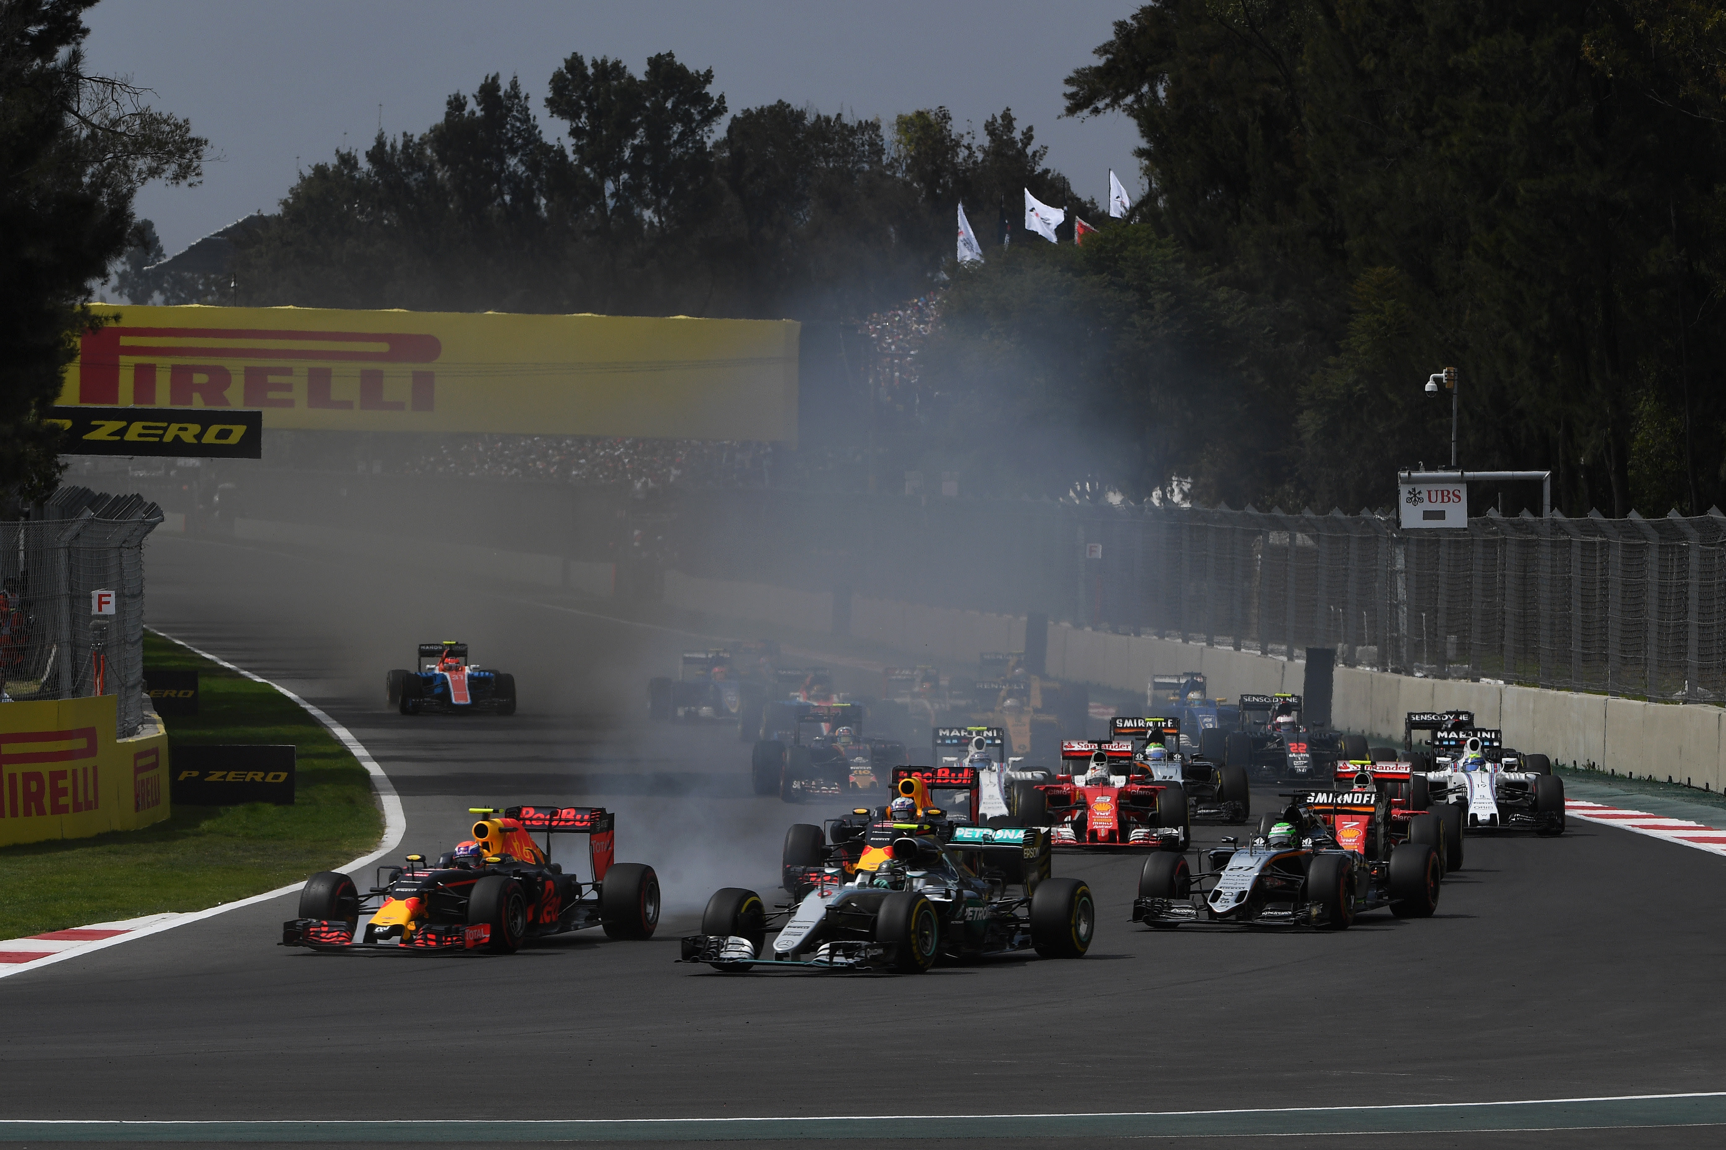

Early on, all access to the facility witnessed a constant influx, also the different zones of the place, where activities such as the F1 Game Zone, the F1 Village and all stages with live concerts kept always in action and movement.

Before the race began, it was carried out the traditional drivers’ parade, followed by the singing of Mexico’s National Anthem performed by a chorus of Rarámuri little girls from Yermo and Parres de Carichí communities in Chihuahua. Finally, there was a deployment of Mexican Airforce’s planes which left a trail on Green, White and red behind their pass.

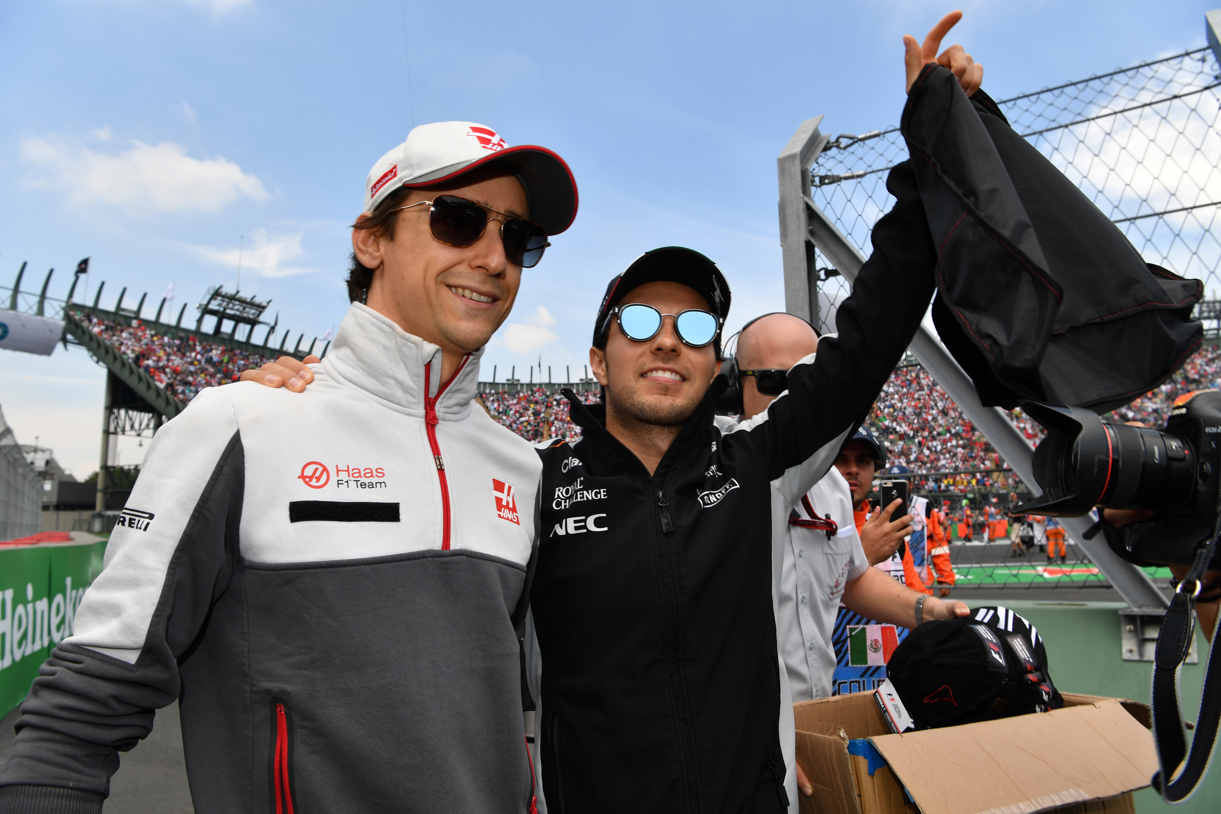

After an exciting race, Lewis Hamilton conquered the first position of the podium, followed by Nico Rosberg, both from Mercedes team, and in the third position Sebastian Vettel from team Ferrari, who after a last-minute decision step up into the podium thanks to the Dutch driver from Red Bull, Max Verstappen’s penalization.

Both Mexican drivers were cheered by the Mexican audience at each of their laps: Sergio ‘Checo’ Perez added a point after reaching the 10th place while Esteban Gutierrez finished 19th.

The FORMULA 1 GRAN PREMIO DE MEXICO 2016’s podium was again spectacular, Lewis Hamilton, Nico Rosberg and Sebastian Vettel received their trophies before thousands of excited fans.

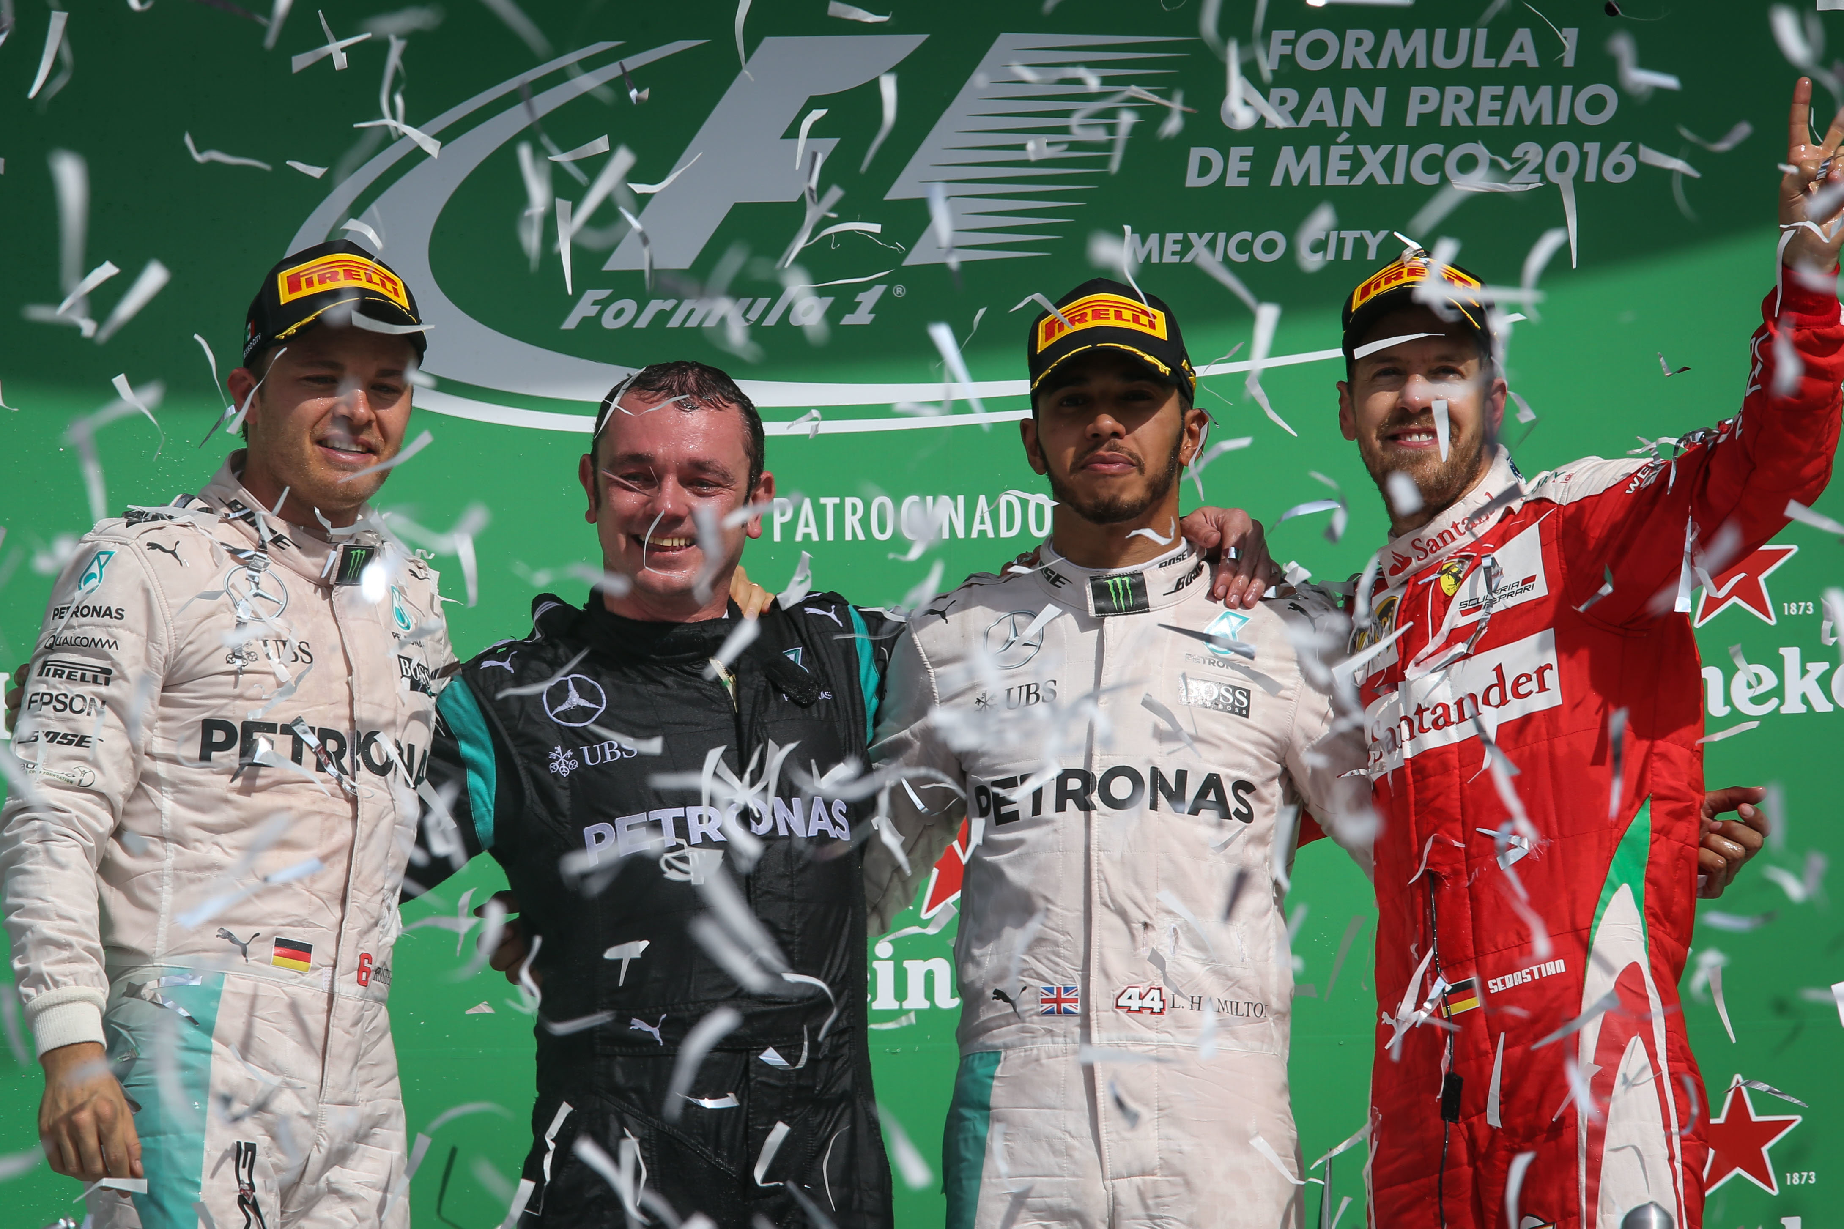

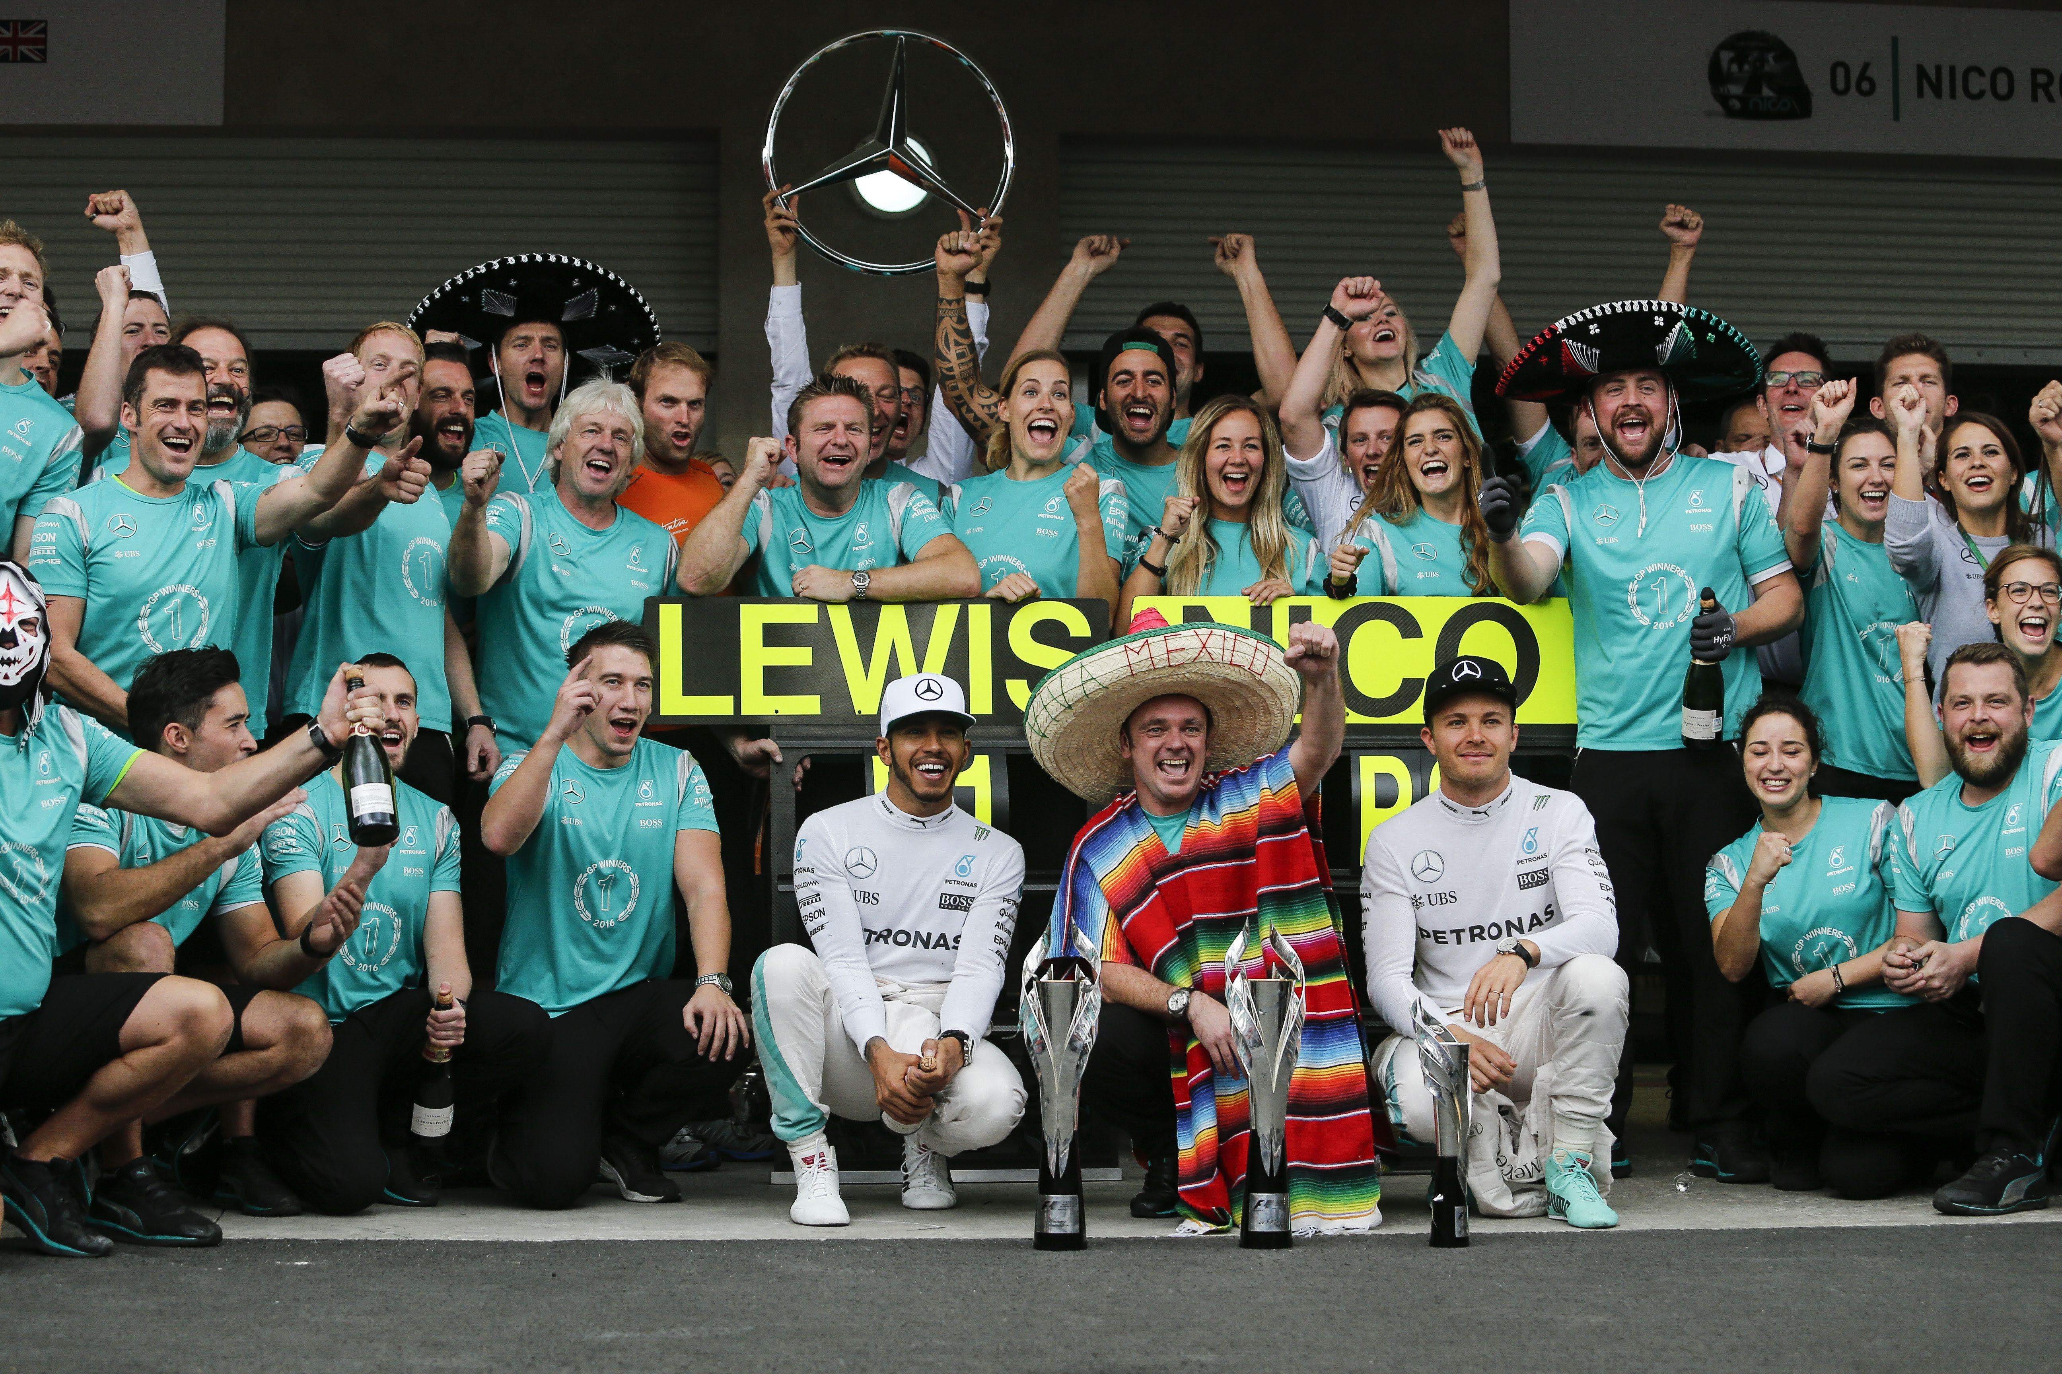

The award ceremony was conducted by Enrique de la Madrid, Secretary of Tourism of the Mexican Republic, who delivered the first place trophy to the British driver; Carlos Slim Domit, Chairman of the Board of Directors of America Movil and Telmex, awarded the second place, besides Horacio de la Vega, Director of the Sport Institute of Mexico City, who granted the trophy for the third place, Sebastian Vettel.

On supporting categories, K. Kubota won the victory during the second Masters Historic Racing competition, aboard a Lotus 78. On the other hand, the Guayanese, Calvin Ming, showed his talent when winning the entertaining F4 NACAM race.

Among celebrities and figures that attended the event, there were the professional tennis player, Serena Williams, Mexico’s former president Felipe Calderón, the Spanish former football player Carles Puyol, Lenox Lewis – former professional boxer–, Ximena Navarrete Miss Universo 2010’s winner and top model Petra Nemcova.

All Mexico celebrated the F1ESTA during FORMULA 1 GRAN PREMIO DE MEXICO 2016’s return second edition.

Para descargar imágenes en alta da clic aquí

All pictures in the link are courtesy of Sutton Images.

-or-
www.mexicogp.mx
Facebook: mexicogp
Instagram/Twitter: @mexicogp
#MexicoGP #F1ESTA #F1EBRE

Contact:
Francisco Velázquez  fvelazquezc@cie.com.mx  (52 55) 52019089  CIE | Manuel Orvañanos  manuel@bandofinsiders.com  (52 55) 63866686  Band of Insiders

About CIE
Corporacion Interamericana de Entretenimiento, S.A.B de C. V.
www.cie.com.mx
We are the market leader in outdoor entertainment in Mexico, Colombia and Central America and one of the major players in the entertainment industry in Latin America and across the globe.
CIE offers a variety of world-class entertainment options including concerts, theater productions, and sports and family and cultural events, among others, to meet our market segments’ needs for recreation and entertainment through its unique vertical integration model that provides the only access available to an extensive network of entertainment centers, advertisers, including the main advertising investors in our markets, and partnerships and strategic alliances with experienced global partners.
We operate an amusement and water park in Bogota, Colombia, and manage Centro Banamex in Mexico City, one of the largest convention and exhibition facilities across the globe. We are recognized as the foremost producer and organizer of special and corporate events in Mexico, and we operate one of the most professional contact centers in the Mexican market.
CIE is a public company whose shares and debt securities are listed on the Mexican Stock Exchange.

