# Mexico City, December 1, 2016.

#### ****Mexico is Formula 1’s Best Event of the Year for the second year in a row; CIE will be awarded “Best Promoter of the Year”****

#### Mexico turned out to be the winner over other 20 venues of FIA Formula One World Championship

#### FIA Prize Giving’s Gala 2016 will take place at the Hofburg Imperial Palace in Vienna, where CIE will be awarded for the second time consecutively.

#### Alejandro Soberón Kuri, President and CEO at CIE will receive the award.

#### Next Friday, December 2, will take place the traditional FIA’s Prize-Giving gala, a glamorous event to award the most outstanding in world motor sport, having Hofburg Imperial Palace in Vienna, Austria as stage this time.

#### For the second consecutive year, the FORMULA 1 GRAN PREMIO DE MEXICO™ will be awarded Formula 1 Best Event of the Year, while organizers of the Mexican race – Corporacion Interamericana de Entretenimiento (CIE) – will get one of the best awards of the evening: “Best Promoter Award”.

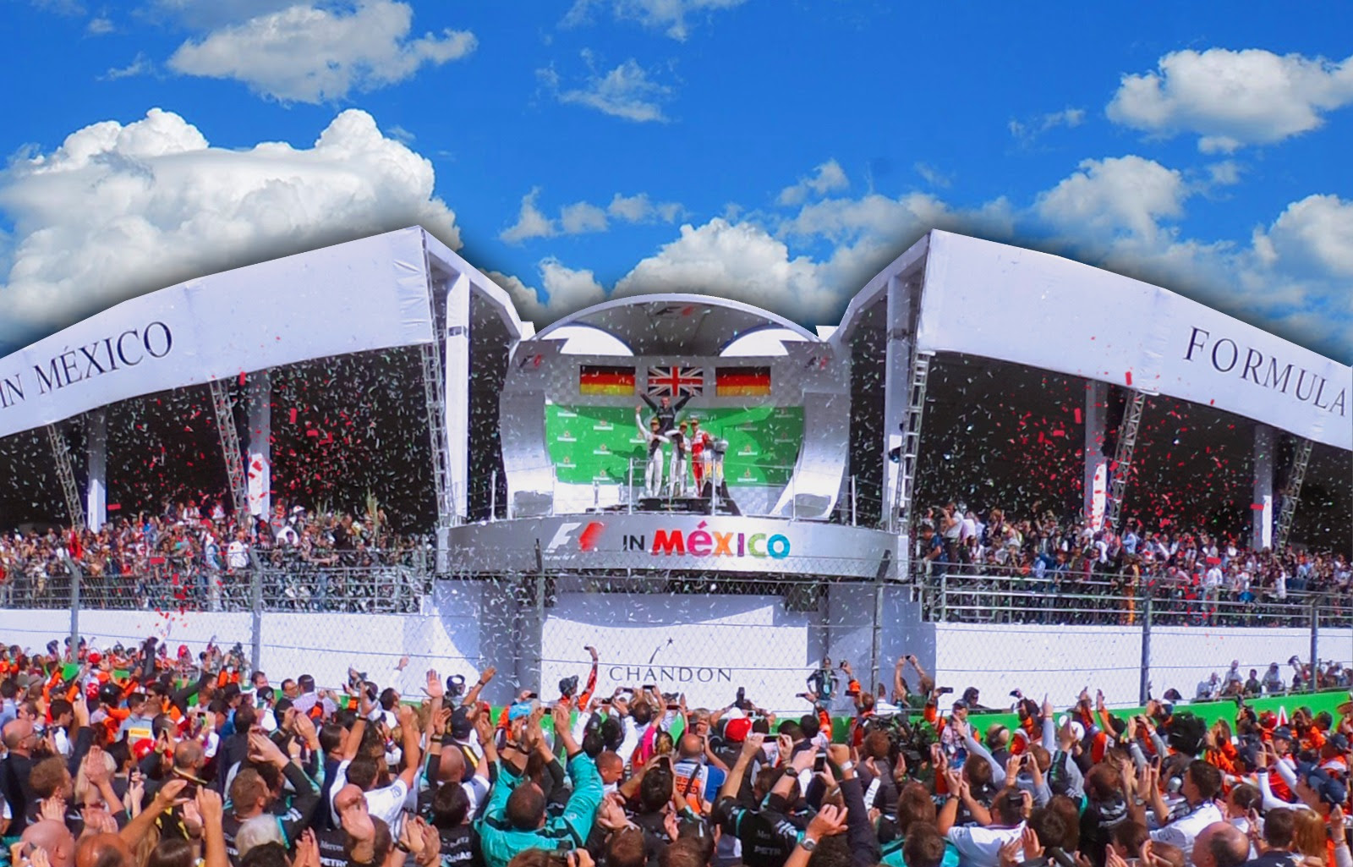

#### After receiving the news, President of FORMULA 1 GRAN PREMIO DE MEXICO 2016™ – Alejandro Soberón Kuri – stated: “Being awarded for the second year in a row is an honor without a doubt. This achievement is the result of the the hard work of thousands of people over the whole year, we made a great effort organizing an event of such importance within the top category in motor racing. We feel every day more proud that through this effort, the eyes of the world are now upon Mexico’s name and warmth”. The executive will attend the ceremony to receive the trophy in person.

#### This award is one of the most important prizes granted by FIA and FOM in Formula1’s category. The award for best promoter, takes into account track’s quality, planning, logistic and implementation of the event, besides rewarding attendees’ enthusiasm, aspect that has distinguished Mexican audience, due to its devotion and passion for this sport.

#### “On behalf CIE I want to thank FIA and FOM for this award, we honestly appreciate also: the Federal Government through the Tourism Secretariat and Mexican Council for Tourism Promotion, Mexico City Government and Sports Institute in Mexico City, OMDAI FIA Mexico, our sponsors, mass media and above all, all those fans who joined our F1ESTA. This new achievement could have never been possible without their participation and support”, added the also President and CEO at CIE.

#### Like the previous edition, the FORMULA 1 GRAN PREMIO DE MEXICO 2016™ stood out for getting positive comments by drivers, teams, media and fans. This award reiterates our country and our people’s ability to offer events of such level.

#### In this respect, Chief Executive at Formula One Management (FOM), Bernie Ecclestone himself, said: “I congratulate Mexico and CIE as promoters of the race, they did a great job again! After 2015’s success they faced a challenge more difficult to overcome, but I got pleasantly impressed with what we witnessed in 2016. Mexico proved again to be a country with the ability to hold events of such high level and now its Grand Prix has become an example to follow”.   “This award recognizes the extraordinary promotion and organization of the Grand Prix, as well as Mexican audience’s incredible warmth and passion. Mexico did it again!” he said.

#### FIA Prize Giving is held every year as a closure for the General Assembly, representing the end of the season and a party where all motor racing champions celebrate their triumphs gotten in the year.

#### Other awards granted by FIA and FOM in Formula 1 category will be:

#### World Championship – Driver

#### World Championship – Builders

#### Best TV Broadcasting of the Year

#### Best Sport National Association

|  |  |
| --- | --- |
| |  | | --- | |  | |

|  |  |
| --- | --- |
| |  | | --- | | Click here to download high definition pictures | |

|  |  |  |  |  |  |  |  |  |  |  |  |  |  |  |  |
| --- | --- | --- | --- | --- | --- | --- | --- | --- | --- | --- | --- | --- | --- | --- | --- |
| |  |  |  |  |  |  |  |  |  |  |  |  |  |  |  | | --- | --- | --- | --- | --- | --- | --- | --- | --- | --- | --- | --- | --- | --- | --- | | |  |  |  |  |  |  |  |  |  |  |  |  |  |  | | --- | --- | --- | --- | --- | --- | --- | --- | --- | --- | --- | --- | --- | --- | | |  |  |  |  |  |  |  |  |  |  |  |  |  | | --- | --- | --- | --- | --- | --- | --- | --- | --- | --- | --- | --- | --- | | |  |  |  |  | | --- | --- | --- | --- | | |  |  |  | | --- | --- | --- | | |  |  | | --- | --- | |  | [Share](http://mexicogp.us14.list-manage.com/track/click?u=ea1f55ab424273afe6dd0d68b&id=2748792685&e=edb6305755" \t "_blank) | | |  |  |  |  |  | | --- | --- | --- | --- | | |  |  |  | | --- | --- | --- | | |  |  | | --- | --- | |  | [Tweet](http://mexicogp.us14.list-manage.com/track/click?u=ea1f55ab424273afe6dd0d68b&id=366bed1172&e=edb6305755" \t "_blank) | | |  |  |  |  |  | | --- | --- | --- | --- | | |  |  |  | | --- | --- | --- | | |  |  | | --- | --- | |  | [Forward](http://us14.forward-to-friend.com/forward?u=ea1f55ab424273afe6dd0d68b&id=b954650b42&e=edb6305755" \t "_blank) | | | | | | |
| |  |  |  | | --- | --- | --- | | -or-   [www.mexicogp.mx](http://mexicogp.us14.list-manage.com/track/click?u=ea1f55ab424273afe6dd0d68b&id=23df0c1103&e=edb6305755" \t "_blank) Facebook: mexicogp Instagram/Twitter: @mexicogp #MexicoGP #F1ESTA #F1EBRE     **Contact:**   |  |  | | --- | --- | | Francisco Velázquez [fvelazquezc@cie.com.mx](mailto:fvelazquezc@cie.com.mx" \t "_blank) (52 55) 52019089 CIE | Manuel Orvañanos [manuel@bandofinsiders.com](mailto:manuel@bandofinsiders.com" \t "_blank) (52 55) 63866686 Band of Insiders | | |

|  |  |
| --- | --- |
| |  | | --- | | **Aboout CIE** Corporacion Interamericana de Entretenimiento, S.A.B de C. V. [www.cie.com.mx](http://www.cie.com.mx/" \t "_blank)   We are the market leader in outdoor entertainment in Mexico, Colombia and Central America and one of the major players in  the entertainment industry in Latin America and across the globe.  CIE offers a variety of world-class entertainment options including concerts, theater productions, and sports and family and  cultural events, among others, to meet our market segments’ needs for recreation and entertainment through its unique  vertical integration model that provides the only access available to an extensive network of entertainment centers,  advertisers, including the main advertising investors in our markets, and partnerships and strategic alliances with  experienced global partners.  We operate an amusement and water park in Bogota, Colombia, and manage Centro Banamex in Mexico City, one of the  largest convention and exhibition facilities across the globe. We are recognized as the foremost producer and organizer of  special and corporate events in Mexico, and we operate one of the most professional contact centers in the Mexican market.  CIE is a public company whose shares and debt securities are listed on the Mexican Stock Exchange. | |