Mexico City, March 23, 2017

ALDF appointed Alejandro Soberón “Ambassador of Tourism of CDMX”

- Along with Carlos Slim Domit and José Abed, he received the appointment from FORMULA 1 GRAN PREMIO DE MÉXICO™.
- CDMX got TV broadcast around 185 countries thanks to FORMULA 1 GRAN PREMIO DE MÉXICO™.
- CDMX got over 33 billion impacts in press world coverage by FORMULA 1 GRAN PREMIO DE MÉXICO™.

The Plenary of Legislative Assembly at Mexico City (ALDF) adopted by majority, Tourism Commission’s proposal of appointing “Mexico City Touristic Ambassadors” in order to disseminate and promote Touristic Heritage, with the aim of increasing the city’s outreach as one of the best tourist destination in the world.

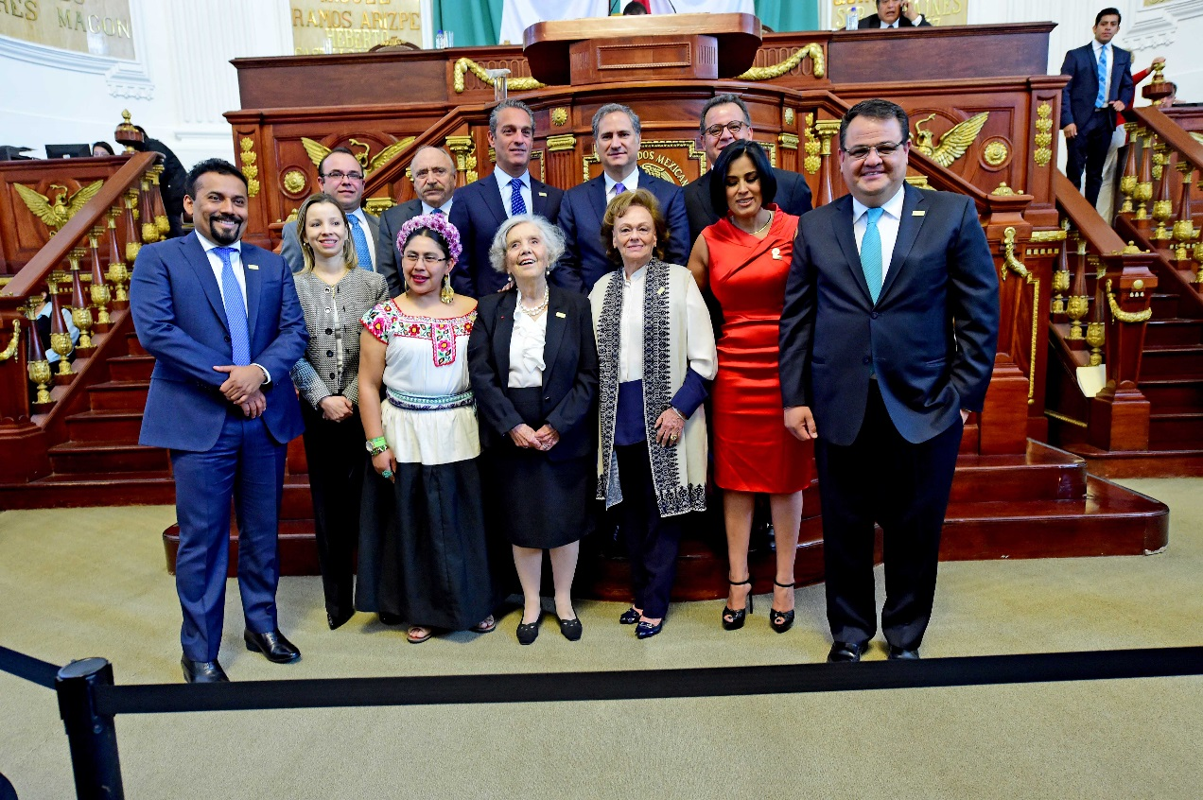
This appointment recognizes work and professional career for different figures who have contributed by encouraging Touristic activity in Mexico City. Such is the case of Alejandro Soberón Kuri, President and CEO of Corporación Interamericana de Entretenimiento (CIE), main promoter of FORMULA 1 GRAN PREMIO DE MÉXICO comeback to Mexico City, event which has turned into one of the biggest tourist attraction in the city. Gathering around 340 thousand spectators, creating 9,400 direct jobs and economic income over 12 billion pesos, only in 2016 edition.
Only as a result of FORMULA 1 GRAN PREMIO DE MÉXICO 2016™, Mexico City reached world media exposure with over 33 billion journalistic notes, over two thousand hours of TV broadcast in 185 countries and 11 billion impacts in social media.
During this ceremony, Carlos Slim Domit highlighted CIE and Alejandro Soberón’s work as one of the most important promoters in Mexico City, thanks to the development of concerts, sport and entertainment events of such global nature in the capital, turning it into one of the greatest tourist destination all around the world due to the entertainment offer that exhibits the capital audience as one of the most helpful hosts with the greatest hospitality for all those who visit this city.
The appointment “Mexico City Touristic Ambassadors” was held during the ordinary session of Mexico City Legislative Assembly, in which figures such as Carlos Slim Domit, José Abed, Elena Poniatowska, Susana Palazuelos, Miguel Alemán Magnani and Fidel Ovando Zavala were also awarded.
To download high-definition pictures click on the following link
https://we.tl/dfJwavBnQe

WWW.MEXICOGP.MX

#MexicoGP #F1ESTA

For further information, follow us on social network:

@Mexico
Mexicogp

MexicoGP
MexicoGP

Contactos de prensa:

CIE  Francisco Velázquez  Gerente de Prensa  T. 52019089  fvelazquezc@cie.com.mx | MAKKEN  Héctor Juárez  Ejecutivo de Cuenta  T. (55) 41600 800 / 900  hector.juarez@makken.com.mx

About Formula 1®:
Formula 1® is the most prestigious motor racing competition in the world that has taken the position of the most popular annual sport competition in the planet: In 2016 the championship was witnessed by 400 million of viewers only from over 200 places.
With a long history of glory and racing written since 1950, Formula 1® has been bastion for great drivers, as well as for iconic teams that had led motor racing to being part of collective memory in millions of fans all around the world.
In 2016 FIA Formula One World Championship™ took place from March to November, including 21 races in 21 countries of the five continents. Formula One World Championship Limited is part of Formula 1® and owns the exclusive commercial rights to FIA Formula One World Championship™.
Formula 1® has being raced in Mexico for 17 times, being editions 2015 and 2016 recognized as “The best Grand Prix of the world”.
For further information about Formula 1® go to: www.formula1.com
For further information about FORMULA 1 GRAN PREMIO DE MEXICO go to: http://www.mexicogp.mx/

About CIE
Corporación Interamericana de Entretenimiento, S.A.B de C. V. www.cie.com.mx
We are the market leader in outdoor entertainment in Mexico, Colombia and Central America and one of the major players in the entertainment industry in Latin America and across the globe.
CIE offers a variety of world-class entertainment options including concerts, theater productions, and sports and family and cultural events, among others, to meet our market segments’ needs for recreation and entertainment through its unique vertical integration model that provides the only access available to an extensive network of entertainment centers, advertisers, including the main advertising investors in our markets, and partnerships and strategic alliances with experienced global partners.
We operate an amusement and water park in Bogota, Colombia, and manage Centro Banamex in Mexico City, one of the largest convention and exhibition facilities across the globe. We are recognized as the foremost producer and organizer of special and corporate events in Mexico, and we operate one of the most professional contact centers in the Mexican market.
CIE is a public company whose shares and debt securities are listed on the Mexican Stock Exchange.

