*Mexico City, June 7, 2017.*

**The F1®ESTA began on the highway  
  
The FORMULA 1 GRAN PREMIO DE MÉXICOTM celebrates the passion for motor racing in our country, bringing back the emotions for The Panamericana® Race.**

|  |  |  |  |  |
| --- | --- | --- | --- | --- |
| |  |  |  |  | | --- | --- | --- | --- | | |  |  |  | | --- | --- | --- | | |  |  | | --- | --- | | |  | | --- | | * *If Mexican Grand Prix focus its attention to fans around the world of this motor sport, for the last 50 years The Panamericana®  Race, was a pioneer , when becoming the focus for all eyes.* * *The adrenalin was deeply felt when a group of special guests drove at over 200kmh a section of a highway near the community Chapa de Mota, State of Mexico.*   Nowadays, the FORMULA 1 GRAN PREMIO DE MÉXICOTM has brought world’s attention to our country, having been the venue of the best Grand Prix of the past two years. In the 50’s, the focus of attention was The Panamericana® Race, that used to bring fans of speed from all over the world to Mexico.    The FORMULA 1 GRAN PREMIO DE MÉXICOTM has always set the goal of exalting the name of Mexico and communicating the world that we are much more than just the cover: we are culture, gastronomy, music and which is also capable of organizing not only an event of global standards but also a trending event.  “Now more than ever, we want to share our country’s richness and talent: bringing Mexico to the world, and at the same time bringing the world to Mexico. That is what encourages us to carry out activities in parallel like this, only five months away from our race”, stated during the event, Rodrigo Sánchez Pedraza, Marketing Director of FORMULA 1 GRAN PREMIO DE MÉXICOTM.  For that matter, The Panamericana® Race is an obvious partner aiming to reach the common goal: placing Mexico as venue for competitions of the greatest world-class legacy. Consequently, yesterday it was commemorated the faithful audience, the great tradition and passion for motor racing in our country, by bringing back one of the most important highway-speed events in the world. | | | | |

Special guests; national and international press members, had the chance of visiting a section of this competition, on the highway of the community Chapa de Mota, State of Mexico, where its people joyously received drivers, guests and the originals cars involved in the competition.

“The Panamericana® Race has always been a reference in motor racing world and this has been a wonderful adventure for those of us who feel the real passion for speed”, said the Mexican driver, Adrián Fernández, one of the participants of this experience and ambassador of FORMULA 1 GRAN PREMIO DE MÉXICOTM.

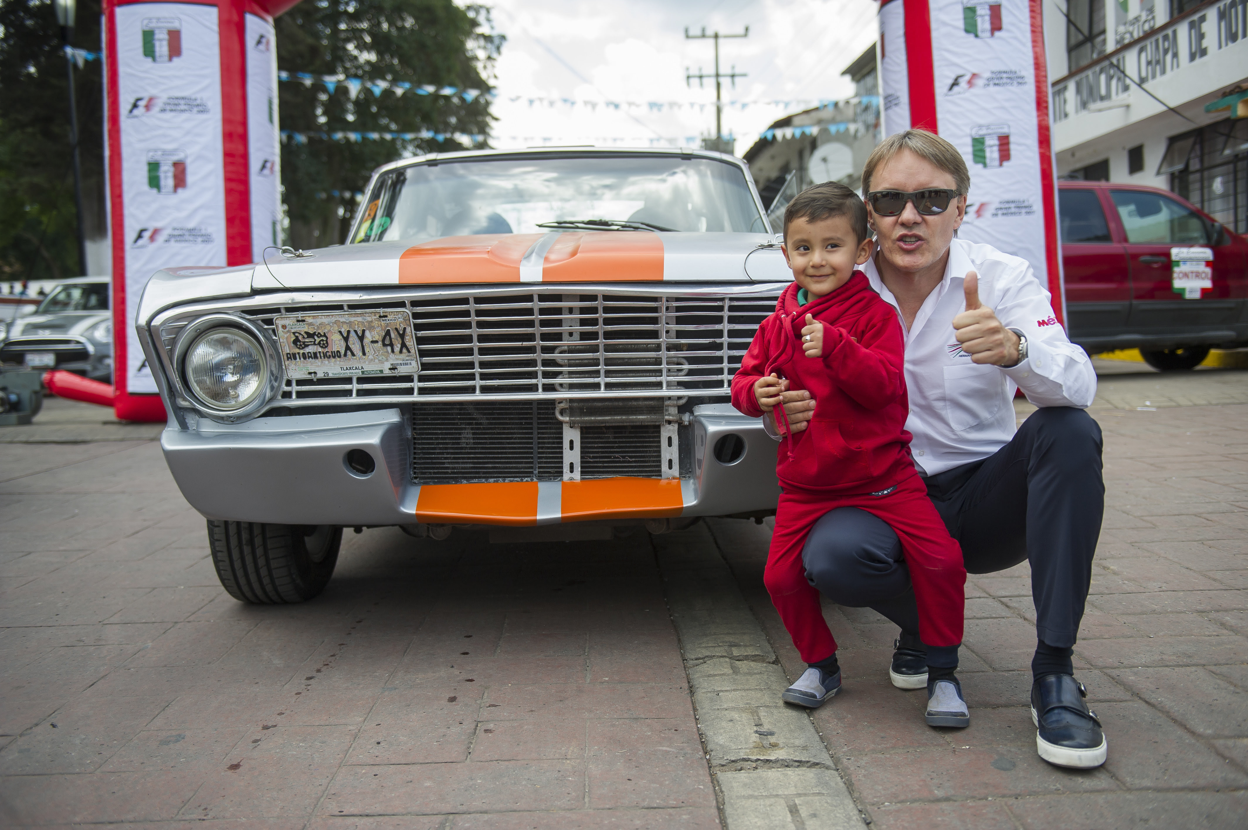

Mexican fans with their passion and devotion, have caused a great impact on drivers, teams and Formula 1® ‘s officials during the past two editions after the return of the motor racing top category to our country; once again people’s warmth and energy turned into the center of attention during the celebration of this experience.

After having experienced the adrenalin at the fullest –after driving 12.5 kilometers on board over a dozen of classic cars at over 200kmh– the attendants shared a feast and the emotions lived during the journey, just five months away from the expected third edition of FORMULA 1 GRAN PREMIO DE MÉXICO.

Click on the following link for more information or pictures downloading:

[https://we.tl/hth5DC96st](http://makken.us15.list-manage.com/track/click?u=60a9969e441299011870ba706&id=133bc9fca0&e=6fdde0c12e" \t "_blank)  
  
[WWW.MEXICOGP.MX](http://makken.us15.list-manage.com/track/click?u=60a9969e441299011870ba706&id=234224dc28&e=6fdde0c12e" \t "_blank)

**#MexicoGP #F1ESTA**

|  |  |  |  |  |
| --- | --- | --- | --- | --- |
| |  |  |  |  | | --- | --- | --- | --- | | |  | | --- | | **CIE** **Francisco Velázquez** Press Manager T. 5201-9089 [fvelazquezc@cie.com.mx](mailto:fvelazquezc@cie.com.mx" \t "_blank) | | |  | | --- | | **MAKKEN María Torres Farber** Account Director T. (55) 41 600 800 / 900 [maria.torres@makken.com.mx](mailto:maria.torres@makken.com.mx" \t "_blank) | | |

**About FORMULA 1 GRAN PREMIO DE MÉXICO™:**

The highest category in motor racing has returned to Mexico, after 23 years of absence, pioneer of the greatest  sport events in our country. With a term from 2015 to 2019 the renewed Autódromo Hermanos Rodríguez is the perfect stage for the return of the F1ESTA to our country, with a highest world-class level track. On its first two editions (2015 and 2016), over 375 thousand people attending the race, turned into the second with the biggest number of spectators around the world (after Great Britain).  Until now, FORMULA 1 GRAN PREMIO DE MÉXICO™ has generated over 22 thousand jobs, economic revenue of 1,119 MDD (24,841 million of pesos).   One more year, Mexico will create a world-class position during racing that will take place from October 27th, to October 29th, after having been awarded as the Best Event of the Year by the maximum authorities in world professional motor racing FIA and FOM, during its first two editions.  For further information about **FORMULA 1 GRAN PREMIO DE MÉXICO™** go:   [http://www.mexicogp.mx/](http://makken.us15.list-manage2.com/track/click?u=60a9969e441299011870ba706&id=45cea032ca&e=de95bc3316" \t "_blank)

**About Formula 1®:**

**Formula 1®** is the most prestigious motor racing competition in the world that has taken the position of the most popular annual sport competition in the planet: In 2016 the championship was witnessed by 400 million of viewers only from over 200 places.

With a long history of glory and racing written since 1950, **Formula 1®** has been bastion for great drivers, as well as for iconic teams that had led motor racing to being part of collective memory in millions of fans all around the world.

In 2016 **FIA Formula One World Championship**™ took place from March to November, including 21 races in 21 countries of the five continents. **Formula One World Championship Limited** is part of Formula 1® and owns the exclusive commercial rights to **FIA Formula One World Championship™.**

**Formula 1®** has being raced in Mexico for 17 times, being editions 2015 and 2016 recognized as “The best Grand Prix of the world”. For further information about **Formula 1®** go to: : [www.formula1.com](http://makken.us15.list-manage.com/track/click?u=60a9969e441299011870ba706&id=e3f98993ff&e=de95bc3316" \t "_blank)

**About CIE**

Corporación Interamericana de Entretenimiento, S.A. de C. V. [www.cie.com.mx](http://makken.us15.list-manage1.com/track/click?u=60a9969e441299011870ba706&id=8c7726e1ca&e=de95bc3316" \t "_blank)

We are the market leader in outdoor entertainment in Mexico, Colombia and Central America and one of the major players in the entertainment industry in Latin America and across the globe.

CIE offers a variety of world-class entertainment options including concerts, theater productions, and sports and family and cultural events, among others, to meet our market segments’ needs for recreation and entertainment through its unique vertical integration model that provides the only access available to an extensive network of entertainment centers, advertisers, including the main advertising investors in our markets, and partnerships and strategic alliances with experienced global partners.

We operate an amusement and water park in Bogota, Colombia, and manage Centro Banamex in Mexico City, one of the largest convention and exhibition facilities across the globe. We are recognized as the foremost producer and organizer of special and corporate events in Mexico, and we operate one of the most professional contact centers in the Mexican market.

CIE is a public company whose shares and debt securities are listed on the Mexican Stock Exchange.

|  |
| --- |
|  |